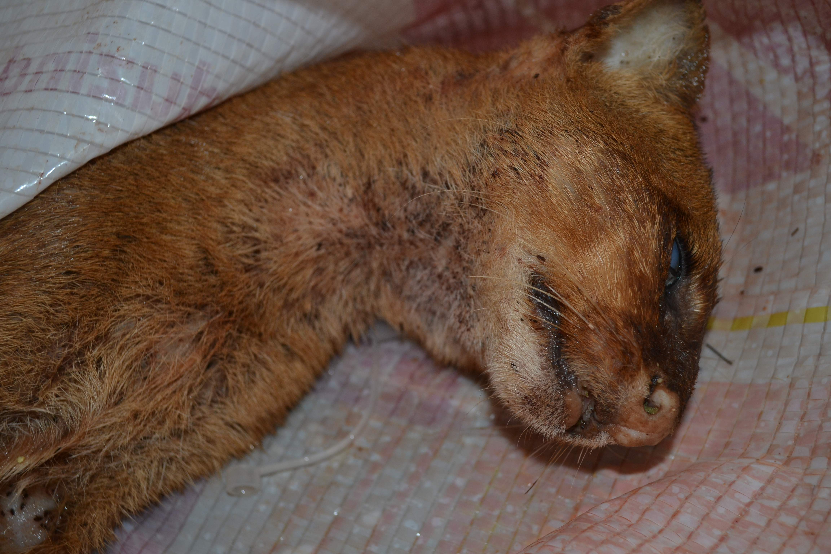
Fig. 1 Visual inspection of deceased female jaguarundi. Intense flea infestation can be observed especially in the ventral area of the neck.
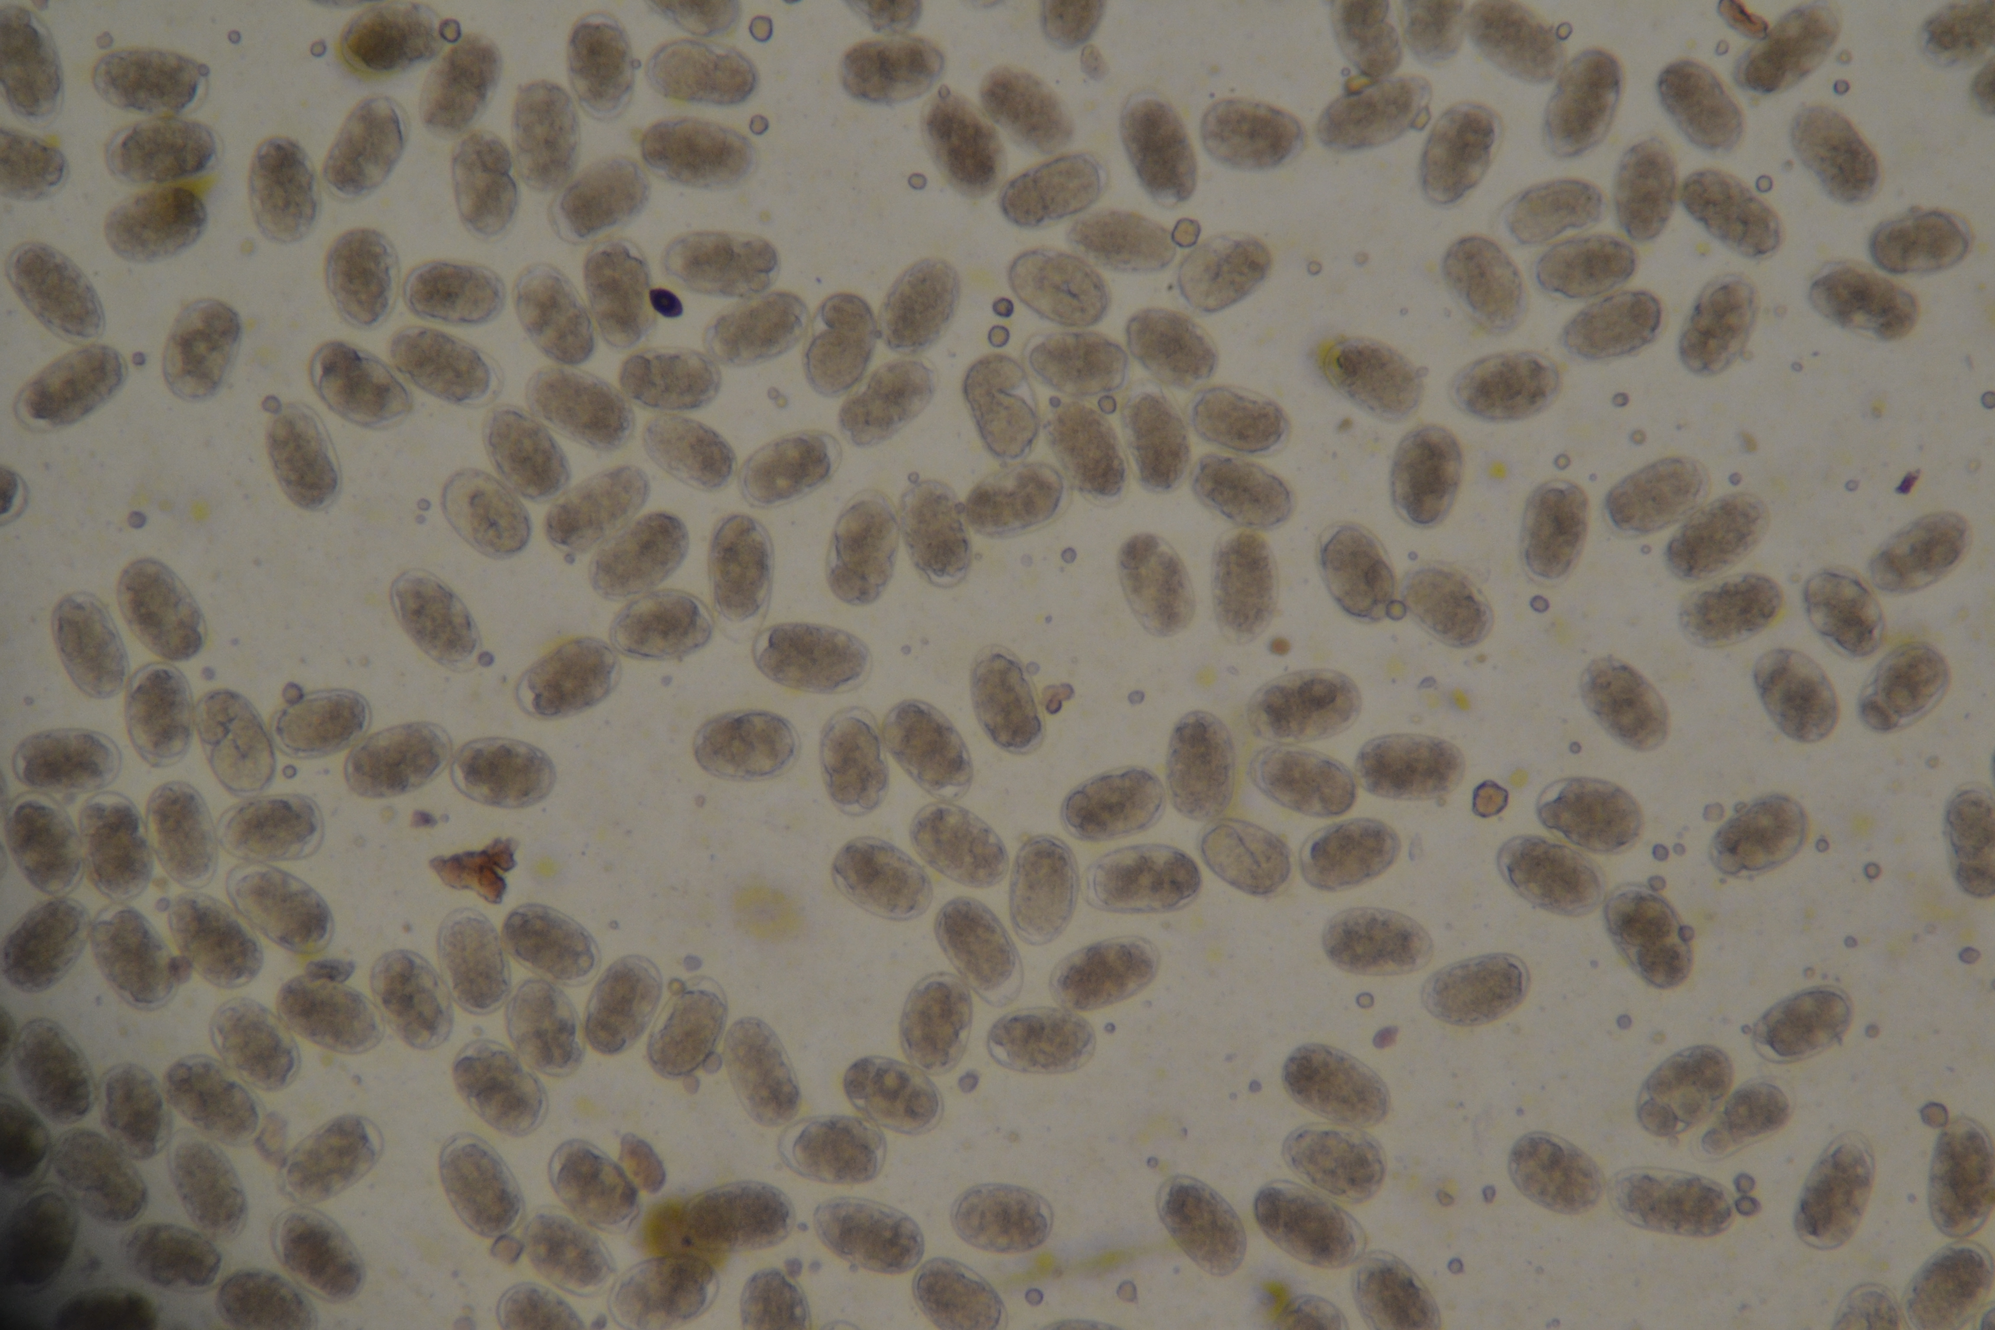
Fig. 2 Ancylostoma eggs observed in fecal sample (40x)

