MANUSCRIPT SUBMISSION LETTER
Date 3. 1. 2017
Dear Editor,
I, L. B. Chaudhary, on behalf of my co-authors, Arun Kumar Kushwaha and Lalit Mohan Tewari submit the following manuscript titled “Phytodiversity of Sonbhadra District, Uttar Pradesh: A Checklist” for publication consideration in the Journal of Threatened Taxa. I understand the objectives of the journal and have formatted the manuscript to fit the style and needs of Journal of Threatened Taxa. I also understand the procedure followed in the review process.
I affirm that the manuscript has been prepared for and sent only to the Journal of Threatened Taxa for publication consideration and not submitted to any other journal or any other type of publication (including web hosting) either by me or any of my co-authors.
Referee/s who may be considered for reviewing this manuscript are:
Name | Working Email | Address
Dr. S. K. Srivastava  Scientist-E & Incharge | skshri08@rediffmail.com | Botanical Survey of India, Northern Regional Centre, 192 Kaulagarh Road, Dehra Dun, Uttarakhand
P. Lakshminarasimhan Scientist-E & Head of Office | lakshminarasimhanp@yahoo.co.in | Botanical Survey of India  Western Regional Centre  7-Koregaon Road  Pune 411 001, India
Dr. R. L. S. Sikarwar  Senior Research Officer | rlssikarwar@rediffmail.com | Arogyadham, Deendayal Research Institute,  Chitrakoot, Dist. Satna (M.P.) - 485780
I attach the checklist for your reference.
Thanking you,
(Signature)
Name: Lal Babu Chaudhary
Affiliation: Plant Diversity, Systematics and Herbarium Division, CSIR-National Botanical Research Institute, Rana Pratap Marg, Lucknow-226 001, Uttar Pradesh
Correspondence email id: dr_lbchaudhary@rediffmail.com
CHECKLIST
Title: Phytodiversity of Sonbhadra District, Uttar Pradesh: A Checklist
Running Title: Phytodiversity of Sonbhadra District
Authors: Arun Kumar Kushwaha, Lalit Mohan Tewari & Lal Babu Chaudhary
Date submitted: 3. 1. 2017
Category submitted under: Article
Number of files submitted:
Content | No. of files | File type (eg. WORD, JPEG, PNG)
Text | 1 | WORD
Tables | 1 | WORD
Figures (Illustrations, line maps, etc) | 1–5 | JPEG
Images (Photographs, composite maps, etc.) | 1–6 | JPEG
Appendices

Check if the following are provided along with the main article except in Letter, Opinion or Book review: Following have been included in the manuscript as per guidelines
Abstract (not more than 247 words)
Keywords (not more than 8 words)
Citation in text as per JoTT format
References as per JoTT format

In case of Paper, Communication or Review article, check if the following are also provided
Author details (not more than 50 words per author)
Mr. Arun Kumar Kushwaha: Working since last five years on different aspects of angiosperm taxonomy, specially on floristic. Email ID: akushwaha072@gmail.com
Prof. Lalit Mohan Tewari: Working on plant taxonomy/ ecology and guiding Ph. D. students. Email ID: l_tewari@redeffmail.com
Dr. Lal Babu Chaudhary: Working since last 29 years on different aspects of angiosperm taxonomy and teaching and guiding Ph. D. students. Email ID: dr_lbchaudhary@rediffmail.com

Author contribution (role of each author in preparation of manuscript or part in project; keep it concise)
Mr. Arun Kumar Kushwaha: Survey, collection, identification and writing manuscript.
Prof. Lalit Mohan Tewari: Provided guidelines and discussion on the subject.
Dr. Lal Babu Chaudhary: Survey, collection, identification, structure of manuscript and overall management of the work.

Institution and sponsor logos (separate good quality JPEGs or TIFFs)

CSIR- National Botanical Research Institute, Lucknow

Phytodiversity of Sonbhadra District, Uttar Pradesh: A Checklist

Arun Kumar Kushwaha¹, Lalit Mohan Tewari² & Lal Babu Chaudhary¹*
¹Plant Diversity, Systematics and Herbarium Division, CSIR-National Botanical Research Institute, Rana Pratap Marg, Lucknow-226 001, Uttar Pradesh
²Department of Botany, D.S.B. Campus, Kumaun University, Nainital-263 002, Uttarakhand
*E-mail: dr_lbchaudhary@rediffmail.com

Abstract: The present study provides a taxonomic account of angiosperms of Sonbhadra district in Uttar Pradesh. The district which comes under vindhyan region of Uttar Pradesh, is one of the richest areas in the state as far as plant diversity is concerned. It is spread over about 6788 km² of geographical area which constitutes about 36% forest cover on highly undulated land. The extensive survey of the area conducted during 2011–2016, critical examination of previous collections housed at various herbaria and review of published literature have resulted in a total of 705 species belonging to 459 genera under 110 families. Out of which, 541 species (76.73%) under 354 genera (77.12%) and 89 families (80.90%) belong to dicots and 164 species (23.26%) under 105 genera (23.26%) and 21 families (19.09%) to monocots. The present enumeration of the species also includes about 76 those species which are cultivated in the area for various purposes. The family Fabaceae (110 spp.) comprises of maximum number of species followed by Poaceae (89 spp.), Asteraceae (38 spp.), Cyperaceae (33 spp.) and Malvaceae (33 spp.). Some of the largest genera in the area are: Cyperus (14 spp.), Ipomoea (9 spp.), Solanum (9 spp.), Ficus (9 spp.), Crotalaria (7 spp.), Desmodium (7 spp.), Bauhinia (6 spp.), Hibiscus (6 spp.), Fimbristylis (6 spp.), Acacia (5 spp. ) etc. The entire forest is chiefly dominated by trees like Acacia catechu (L.f.) Willd., Boswellia serrata Roxb. ex Colebr., Butea monosperma(Lam.) Taub., Hardwickia binata Roxb. and Shorea robusta Gaertn.

Keywords: Floristic diversity, Vindhyan region, Sonbhadra District, Uttar Pradesh.

INTRODUCTION
The floristic account provides lots of information of plant wealth of an area which may be beneficial for university students, botanists, researchers, NGO's, naturalists, environmental engineers, forest managers, conservation biologists, policy makers etc. Knowledge of floristic composition and structure of forest are also useful in identifying ecologically and economically important plants and analysing their diversities and also protecting threatened plants (Addo-Fordjour et al., 2009). In past, many important floristic accounts have been published for several states, districts and biogeographic regions of India and abroad. In addition to general flora of Uttar Pradesh (Duthie, 1903–1929, Kanjilal, 1966, Rau, 1969, Uniyal et al., 1999; Chaudhary et al. 2016), several work related with different districts and national parks and sanctuaries have also been produced by many workers (Kanjilal, 1933; Srivastava, 1938; Singh, 1969; Srivastava, 1976; Sharma & Pandey, 1984; Sharma & Dhakre, 1995; Verma & Ranjan, 1995; Singh, 1997; Saini, 2005; Singh & Khanuja, 2006; Kumar et al., 2015). However, the floristic account of Sonbhadra district of Uttar Pradesh is still awaited since long inspite of its rich diversity. Until or unless the documentation of plant wealth of all districts of the state is not fully achieved, the idea to produce a comprehensive flora of the whole state will be incomplete. Hence, there is a need for proper inventorisation and documentation of all plants available in Sonbhadra district with their up to date taxonomic information. Since, the area is very rich in minerals and forest resources, many industries and factories of different kinds have been developed here. Therefore, the present study will also be very important for a comparative study of the plants of the area in future and also to examine the effects of industrial pollutants on them.
Although, the district has not been thoroughly inventorised earlier, however, the reference on the plants of study area are available in Bhattacharyya (1963, 1964) and Srivastava (1955) wherein the plants of erstwhile Mirzapur district have been dealt. In these studies about 460 species have been listed including about 130 species from the study area. In addition, a few scattered work chiefly pertaining to the ethnobotanical and medicinal plants have also been carried out from the area (Singh et al., 2002; Chaudhary, 2010; Singh et al., 2010; Singh et al., 2012; Singh & Dubey, 2012; Mishra et al., 2012). Recently, Kushwaha et al. (2016 a, b) have thoroughly studied the family Cucurbitaceae of the area and have also presented a preliminary overview of angiospermic plants. Hence, the present work is the first study of its kind from the study area after its recognition as a district.

MATERIALS AND METHODS
In this study, 12 field tours in different seasons have so far been conducted between 2011–2015 to survey the area. The plant materials were collected either in flowering or fruiting or in both stages with detailed information such as habit, habitat, colour of flowers and fruits, shape and size of trees, nature of bark of trees, GPS information, conservation status etc. The herbarium specimens were prepared following standard procedure out lined by Lawrence (1951) and Jain & Rao (1977). The identification of species was made with the help of different floras and important taxonomic works (Hooker, 1872–1897; Duthie, 1903–1929; Brandis, 1906; Singh, 1997) and also after matching with the authentic specimens housed at various Indian herbaria like BSA, BSD, CAL, DD and LWG. All specimens collected in the present study have been deposited at LWG for future records. In the present treatment, each species has been furnished with correct recent name following websites like GRIN, IPNI, ILDIS, The Plantlist, Wikipedia, Tropicos etc., growth form (habits) and reference to voucher specimens along acronym of the herbarium where specimens are dposited. The families and genera and species within genus have been arranged alphabetically in the list. The cultivated species have been marked with asterisk mark (*).

STUDT AREA
Uttar Pradesh, one of the largest states of India with an area of about 240928 km², has been divided into 75 districts. However, its forest cover is about 16,583 km² which is only 6.88 % of its total geographical area (Anonymous, 2011). In the present study, Sonbhadra district has been selected for the floristic study to know the plant wealth of the area (Figure 1). Sonbhadra district was carved out from the district Mirzapur on 4th March 1989. It is 2nd largest district of the state comprising about 6788 km² geographical area. It lies between 24° 41′ 23″ N, 83° 3′ 55″ E at elevations range from 315 – 485 m. The temperature of the area varies from 32°C – 42°C in the summer and 2°C – 15°C in the winter. This district is situated in the extreme south-east of the state and is bounded by Mirzapur district in the north-west, Chandauli district in the north, Kaimur and Rohtas districts of Bihar in the north-east, Garhwa district of Jharkhand state in the east, Koriya and Surguja districts of Chhattisgarh state in the south and Singrauli district of Madhya Pradesh in the west. The district occupies 36.79% (i.e. 3782.86 km²) forest cover of its geographical area in the state. The topography of the area is uneven due to presence of hillocks. The area which comes under vindhyan plateau of the state has tropical dry deciduous forest (Singh & Dubey, 2012) (Image 1).

RESULT AND DISCUSSION
The whole of the areae is covered with natural scrubby jungle and thick forests. Almost entire plateau represents a uniform horizontal stratification of rocks. On the top of plateau these rocks are unsuitable for the growth of broad leaved plants and therefore, represented by uniform scrubby dry vegetation. The borad leaved plants are generally seen on the slopoe of plateau. Over all, the entire forest is mixed dry deciduous, but evergreen trees are frequently seen in ravines. The data collected from field and herbarium studies reveal that the entire area contains about 705 species under 459 genera and 110 families including 76 cultivated ones which have been planted in the area for different purposes (Table-1). Out of that, 541 species (76.73%) under 354 genera (77.12%) and 89 families (80.90%) belong to dicots and 164 species (23.26%) under 105 genera (22.87%) and 21 families (19.09%) to monocots (Figure 2). The family Fabaceae have maximum number of species (52 Genera, 110 species) followed by Poaceae (63 Genera, 89 species), Asteraceae (32 Genera, 38 species), Malvaceae (15 Genera, 33 species), Cyperaceae (9 Genera, 33 species), Cucurbitaceae (11 Genera, 20 species), Acanthaceae (11 Genera, 17 species), Convolvulaceae (8 Genera, 17 species), Solanaceae (5 Genera, 16 species) and Rubiaceae (13 Genera, 15 species) (Figure-3). Some of the dominant genera in the forest are Cyperus (14 spp.), Ipomoea (9 spp.), Solanum (9 spp.), Ficus (9 spp.), Crotalaria (7 spp.), Desmodium (7 spp.), Bauhinia (6 spp.), Hibiscus (6 spp.), Fimbristylis (6 spp.), Acacia (5 spp. ) etc. (Figure 4). Among all plants, 322 species (45.67%) are herbs, 163 species (23.12%) are trees, 120 species (17.02 %) are grasses, 76 species (10.21 %) are shrubs and 28 species (3.97 %) are climbers (Figure-5). Some of the commonly occurring tree species in the forest are Acacia catechu (L.f.) Willd., Anogeissus latifolia (Roxb. ex DC.) Wall. ex Guillem. & Perr., Bridelia retusa (L.) A. Juss., Bauhinia racemosa Lam., Boswellia serrata Roxb. ex Colebr., Butea monosperma (Lam.) Taub. (Image 2A), Cassia fistula L. (Image 2B), Casearia tomentosa Roxb. (Image 2C), Desmodium oojenenensis (Roxb.) H. Ohasi (Image 2D), Diospyros melanoxylon Roxb., Diospyros montana Roxb. (Image 2E), Erythrina stricta Roxb. (Image 2F), Ficus benghalensis L. (Image 3A), Flacoutia indica (Burm.f.) Merr., Haldina cordifolia (Roxb.) Ridsdale, Hardwickia binata Roxb. (Image 3B), Holoptelea integrifolia ( Roxb.)Planch. (Image 3C), Lagerstroemia parviflora Roxb., Madhuca longifolia (J.Koenig ex L.) J.F.Macbr. (Image 3D), Mallotus philippensis (Lam.) Müll.Arg. (Image 3E), Miliusa tomentosa (Roxb.) Sinclair, Leucaena leucocephala (Lam.) de Wit (Image 3F), Mitragyna parvifolia (Roxb.) Korth. (Image 4A), Murraya koenigii (L.) Spreng. (Image 4B), Limonia acidissima Groff (Image 4C), Nyctanthes arbortritis L., Pithecellobium dulce (Roxb.) Benth. (Image 4D), Prosopis juliflora (Sw.) DC. (Image 4E), Shorea robusta Gaertn., Soymida febrífuga (Roxb.) A. Juss., Terminalia bellirica (Gaertn.) Roxb. (Image 4F), Terminalia elliptica Willd etc. Among shrubs Abutilon indicum (L.) Sweet, Adhatoda zeylanica Medik., Barleria cristata L., Calotropis procera (Aiton) Dryand., Capparis zeylanica L. (Image 5A), Cissampelos pareira L., Clerodendrum phlomidis L.f., Crotalaria albida Roth, Desmodium heterocarpon (L.) DC., Gloriosa superb L. (Image 5B), Helicteres isora L., Urena lobata L. (Image 5C), Woodfordia fruticosa (L.) Kurz etc. are frequently seen. Under herbaceous elements Anagallis arvensis L. (Image 5D), Ageratum conyzoides (L.) L. (Image 5E), Bidens pilosa L., Byttneria herbacea Roxb., Crotalaria prostrate Willd., Coccinia grandis (L.) Voigt (Image 5F), Desmodium gangeticum (L.) DC. Elephantopus scaber L., Evolvulus alsinoides (L.) L., Hyptis suaveolens (L.) Poit, Sida cordata (Burm.f.) Borss.Waalk., Solanum incanum L. (Image 6A), Solanum surattense Burm. f., Tephrosia strigosa (Dalzell) Santapau & Maheshw., Triumfetta pentandra A. Rich., Uraria picta (Jacq.) DC., etc. are predominantely occurring species. The conspicuous climbers are Ampelocissus latifolia (Roxb.) Planch., Cryptolepis dubia (Burm.f.) M.R.Almeida, Ipomoea quamoclit L. and Mucuna pruiens (L.) DC. Arundo donax L. (Image 6B), Cyperus compactus Retz., Cyperus glomeratus L., Cyperus compressus L., Desmostachya bipinnata (L.) Stapf (Image 6C), Eleusine indica (L.) Gaertn. (Image 6D), Eragrostis amabilis (L.) Wight & Arn, Eragrostis japonica (Thunb.) Trin., Fimbristylis bisumbellata (Forssk.) Bubani, Fimbristylis dichotoma (L.) Vahl, Fimbristylis tetragona R.Br., Kyllinga brevifolia Rottb. (Image 6E), Leptochloa chinensis (L.) Nees, Polypogon monspeliensis (L.) Desf. (Image 6F) etc. are some of the common grasses in the area.

REFERENCES

Addo-Fordjour, P., S. Obeng, A. Anning & M. Addo (2009). Floristic composition, structure and natural regeneration in a moist semideciduous forest following anthropogenic disturbances and plant invasion. International Journal of Biodiversity and Conservation 1(2): 21–37.
Anonymous (2011). Forest Survey of India. (http://www.fsi.org.in/fsi_projects/annualreport.pdf).
Bhattacharyya, U. C. (1963). A contribution to the flora of Mirzapur-I. Some new records for the district and for the Upper Gangetic Plain. The Bulletin of the Botanical Survery of India, Dehra Dun 5(1): 59–62.
Bhattacharyya, U. C. (1964). A contribution to the flora of Mirzapur-II. The Bulletin of the Botanical Survery of India, Dehra Dun 6(2–4): 191–210.
Brandis, D. (1906). Indian Trees. Archibald Constable & Co. Ltd., London, 767 pp.
Chaudhary, L. B., A. K. Kushwaha & O. Bajpai (2016). Trees of Uttar Pradesh-Part 1. Bennett, Coleman & Co. Ltd., Lucknow, India, 364 pp.
Chaudhary, R. S. (2010). Taxa of family Fabaceae: A potential of local medicinal values in Vindhya Region Uttar Pradesh, India. International Journal of Pharma and Bio Sciences 1(4): B 46–53.
Duthie, J. F. (1903 – 1929). Flora of upper Gangetic plain, and of the adjacent Siwalik and sub-Himalayan tracts. Vol. 1–3. Superintendent of Government Printing, Calcutta, India.
Hooker, J. D. (1872 – 1897). The Flora of British India, Vol. 1-7. Lovell Reeve & Co., London.
Jain, S. K. & R. R. Rao (1977). A handbook of field and herbarium methods. Today & Tomorrow’s Printers & Publishers, New Delhi, 107 pp.
Kanjilal, P. C. (1933). Forest flora of Pilibhit, Oudh, Gorakhpur and Bundelkhand. Narendra Publishing House, Delhi, 427 pp.
Kanjilal, P. C. (1966). A forest flora for the plains of Uttar Pradesh, Vol. 1–3. Lucknow, India.
Kushwaha A. K., O. Bajpai, A. K. Srivastava, L. M. Tiwari & L. B. Chaudhry (2016a). Cucurbitaceae of Sonbhadra district, Uttar Pradesh: Diversity and Uses, pp. 195–206. In: Chaourasia, H.K. (eds.). Conservation of Medicinal plants: Conventional and modern Approaches. Omega Publications, New Delhi, India, 414 pp.
Kushwaha, A. K., N. Singh, L. M. Tewari & L. B. Chaudhary (2016b). A preliminary analysis of angiospermic flora of Sonbhadra District, Uttar Pradesh, pp. 162–166. In: Gupta, S., K. K. Tiwari & H. Kumar (eds.). Mainstreaming Biodiversity; Sustaining People and their Livelihoods. U. P. State Biodiversity Board, Lucnkow, (U.P.), India, 172 pp.
Kumar, A., O. Bajpai, A. K. Mishra, N. Sahu, S. K. Behera, S. S. Bargali & L. B. Chaudhary (2015). A checklist of the flowering plants of Katerniaghat Wildlife Sanctuary, Uttar Pradesh, India. Journal of Threatened Taxa 7(7): 7309–7408; http://dx.doi.org/10.11609/JoTT.o3257.7309-408
Lawrence, G. H. M. (1951). Taxonomy of vascular plants. Oxford IBH Publishing Co. Pvt. Ltd., New Delhi, 823 pp.
Mishra, N. K., R. Das & D. K. Srivastava (2012). Ethno-medicinal weeds of veterinary importance from Dullapathar frontier region of district Sonebhdra (south east U.P.). Indian journal of plant science 2 (1): 109–111.
Rau, M. A. (1969). Flora of the Upper Gangetic Plain & the adjacent Siwalik and sub-himalayan tracts- Check list. The Bulletin of the Botanical Survery of India, Dehra Dun 2(10): 1 – 87.
Saini, D.C. (2005). Flora of Bahraich district, Uttar Pradesh—I, II, III, IV, V, VI. Journal of Economic and Taxonomic Botany 29(3/4): 528–920.
Sharma, A. K. & J. S. Dhakre (1995). Flora of Agra District. Botanical Survey of India, Kolkata, 356 pp.
Sharma, B. D. & J. S. Pandey (1984). Exotic Flora of Allahabad District. Botanical Survey of India, Kolkata, 160 pp.
Singh, A. & N. K. Dubey (2012). An ethno botanical study of medicinal plants in Sonebhadra District of Uttar, Pradesh, India with reference to their infection by foliar fungi. Journal of Medicinal Plants Research 6 (14): 2727–2746.
Singh, A., A. S. Rhaguvanhi & J. S. Singh (2002). Medico-ethnobotany of tribal of Sonaghati of Sonbhadra district, U.P., India. Journal of Ethnopharmacology 8(1): 31–41.
Singh, A., G. S. Singh & P. K. Singh (2012). Medico-ethnobotanical inventory of Renukoot forest division of district Sonbhadra, Uttar Pradesh, India. Indian Journal of Natural Products and Resources 3(3): 448–457.
Singh, K. K. (1997). Flora of Dudhwa National Park. Bishen Singh Mahendra pal Singh, Dehera Dun, 516 pp.
Singh, N. P. (1969). Flora of Bulandsahar District. The Bulletin of the Botanical Survery of India, Dehra Dun 11: 1 – 22.
Singh, P. K., K. Vinod, R. K. Tiwari, A. Sharma, Ch. V. Rao & R. H. Singh (2010). Medico-Ethnobotany of ‘Chatara’ Block of District Sonebhadra, Uttar Pradesh, India. Advances in Biological Research 4 (1): 65–80.
Singh, S. C. & S. P. S. Khanuja. (2006). Lucknow Flora. Central Institute of Medicinal and Aromatic Plants, Lucknow, U.P., viii+522 pp.
Srivastava, G. D. (1938). Flora of Allahabad, 2 parts. Cornell University, New York.
Srivastava, J. G. (1955). A note on the flora of Mirzapur (U.P). Journal of the Bombay Natural History Society 53: 152–153.
Srivastava, T. N. (1976). Flora Gorakhpurensis. Today & Tomorrow’s Printer & Publisher, New Delhi, XL+411 pp.
Verma, B. K. & V. Ranjan. (1995). Flora of Lalitpur district U.P., pp. 87–94. In: Pandey, A. K. (ed.). Taxonomy and Biodiversity . CBS Publishers & Distributors, Pvt. Ltd., New Delhi, 232 pp.
Uniyal, S. K., A. Swami & B. P. Uniyal (1999). Monocotyledonous Plants of Uttar Pradesh – A Chaecklist (excluding Cyperaceae and Poaceae). Bishen Singh Mahendra Pal Singh, Dehra Dun, 142 pp.

ACKNOWLEDGEMENTS: The Director, CSIR-National Botanical Research Institute, Lucknow, India is highly acknowledged for providing facilities. The authors are also thankful to DST, Govt. of India, New Delhi for the financial support. The thanks are also due to the in-charge of herbaria mentioned in the work for granting permission for herbarium consultation. The PCCF (Wildlife), Uttar Pradesh and forest field staffs are also acknowledged for their hospitality and assistance provided during the field work.

Table 1: List of species
Family | Taxa | Growth form | Collection No.
 | DICOT
Acanthaceae | Adhatoda zeylanica Medik. | Shrub | Kushwaha 304140 (LWG)
 | Andrographis echioides (L.) Nees | Herb | Panigrahi 12006 (BSA)
 | Andrographis paniculata (Burm. f.) Wall. ex Nees in Wall | Herb | Kushwaha 304101 (LWG)
 | Barleria cristata L. | Shrub | Kushwaha 254593 (LWG)
 | Barleria prionitis L. | Shrub | Kushwaha 254285 (LWG)
 | Dipteracanthus prostratus (Poir.) Nees | Herb | Panigrahi 12221 (BSA)
 | Elytraria acaulis (L.f.) Lindau | Herb | Kushwaha 304137 (LWG)
 | Hemigraphis hirta (Vahl) T.Anderson | Herb | Kushwaha 304195 (LWG)
 | Hygrophila auriculata (Schumach.) Heine | Herb | Panigrahi 9676 ( BSA)
 | Hygrophila erecta (Burm.f.) Hochr. | Herb | Panigrahi 2059 (BSA)
 | Hygrophila polysperma (Roxb.) T.Anderson | Herb | Panigrahi 13417 (BSA)
 | Justicia diffusa Willd. | Herb | Panigrahi 20504 (BSA)
 | Justicia prostrata Schltdl. ex Nees | Herb | Panigrahi 8451 (BSA)
 | Justicia quinqueangularis K.D.Koenig ex Roxb. | Herb | Panigrahi 2247 (BSA)
 | Peristrophe bicalyculata (Retz.) Nees | Herb | Kushwaha 259263(LWG)
 | Ruellia suffruticosa Roxb. | Shrub | Mishra 9935 (BSA)
 | Rungia pectinata (L.) Nees | Herb | Kushwaha 259237(LWG)
Aizoaceae | Glinus oppositifolius (L.) Aug. DC. | Herb | Singh at al. EBH 249 (LWG)
 | Trianthema portulacastrum L | Herb | Kushwaha 304102 (LWG)
Ampelidaceae | Ampelocissus latifolia (Roxb.) Planch. | Climber | Mishra 9736 (BSA)
Amranthaceae | Achyranthes aspera L. | Herb | Kushwaha 264710 (LWG)
 | Aerva lanata (L.) Juss. | Herb | Kushwaha 254359 (LWG)
 | Allmania nodiflora (L.) R.Br. ex Wight | Herb | Panigrahi 12590 (BSA)
 | Alternanthera ficoidea (L.) Sm. | Herb | Kushwaha 254289 (LWG)
 | Alternanthera paronychioides A.St.-Hil. | Herb | Kushwaha 254690 (LWG)
 | Alternanthera sessilis (L.) R.Br. ex DC. | Herb | Kushwaha 259235 (LWG)
 | Amaranthus spinosus L. | Herb | Kushwaha 254691 (LWG)
 | Amaranthus tricolor L. | Herb | Panigrahi 12631 (BSA)
 | Amaranthus viridis L. | Herb | Kushwaha 254700 (LWG)
 | *Celosia argentea L. | Herb | Kushwaha 245695 (LWG)
 | Digera muricata (L.) Mart. | Herb | Kushwaha 245692 (LWG)
 | Nothosaerva brachiata (L.) Wight | Herb | Kushwaha 304104 (LWG)
Anacardiaceae | Buchanania cochinchinensis (Lour.) M.R.Almeida | Tree | Kushwaha 259255 (LWG)
 | Lannea coromandelica (Houtt.) Merr. | Tree | Kushwaha 259825 (LWG)
 | *Mangifera indica L. | Tree | Kushwaha 259801 (LWG)
 | Semecarpus anacardium L.f. | Tree | Kushwaha 259810 (LWG)
Annonaceae | *Annona squmosa L. | Tree | Kushwaha 254696 (LWG)
 | Miliusa tomentosa (Roxb.) Sinclair | Tree | Kushwaha 259852 (LWG)
 | *Polyalthia longifolia (Sonn.) Thw. | Tree | Kushwaha 254699 (LWG)
 | Polyalthia suberosa (Roxb.) Thwaites | Tree | Kushwaha 259881 (LWG)
Apiaceae | *Anethum graveolens L. | Herb | Singh & Party EBH489 (LWG)
 | Centella asiatica (L.) Urban | Herb | Kushwaha 259883 (LWG)
 | *Coriandrum sativum L. | Herb | Kushwaha 259878 (LWG)
Apocynaceae | *Alstonia scholaris (L.) R. Br. | Tree | Kushwaha 254697 (LWG)
 | Calotropis gigantea (L.) R. Br. | Small tree | Kushwaha 304106 (LWG)
 | Calotropis procera (Aiton) Dryand. | Shrub | Kushwaha 259285 (LWG)
 | *Carissa carandas L. | Small tree | Kushwaha 259812 (LWG)
 | *Cascabela thevetia (L.) Lippold | Tree | Kushwaha 259819 (LWG)
 | Carissa spinarum L. | Shrub | Kushwaha 254363 (LWG)
 | Catharanthus pusillus (Murray) G.Don | Herb | Panigrahi 12587 (BSA)
 | Holarrhena pubescens Wall. ex G.Don | Tree | Kushwaha 259298 (LWG)
 | Ichnocarpus frutescens (L.) W.T.Aiton | Climber | Kushwaha 259849 (LWG)
 | Oxystelma esculentum (L.f.) Sm. | Climber | Kushwaha 304108 (LWG)
 | *Tabernaemontana divaricata (L.) R.Br. ex Roem. & Schult | Tree | Kushwaha 259824 (LWG)
 | Wrightia arborea (Dennst.) Mabberley | Small tree | Kushwaha 304118 (LWG)
 | Wrightia tinctoria R.Br. | Tree | Kushwaha 254509 (LWG)
 | *Plumeria rubra L. | Tree | Kushwaha 304122 (LWG)
 | *Plumeria alba L. | Small tree | Kushwaha 304127 (LWG)
Aristolochiaceae | Aristolochia indica L. | Herb | Kushwaha 304131 (LWG)
Asclepiadaceae | Ceropegia hirsuta Wight & Arn. | Climber | Panigrahi 12577 (BSA)
 | Cryptolepis dubia (Burm.f.) M.R.Almeida | Climber | Panigrahi 9971 (BSA)
 | Gymnema rivulare Schltr. | Climber | Panigrahi 9660 (BSA)
 | Hemidesmus indicus (L.) R. Br. ex Schult. | Herb | Singh & Party EBH735 (LWG)
 | Marsdenia tenacissima (Roxb.) Moon | Woody climber | Mishra 9960 (BSA)
 | Telosma pallida (Roxb.) W. G. Craib | Shrub | Panigrahi 12380 (BSA)
Asteraceae | Acanthospermum hispidum DC. | Herb | Panigrahi 12329 (BSA)
 | Acilepis aspera (Buch.-Ham.) H.Rob. | Herb | Panigrahi 12083 (BSA)
 | Acmella calva (DC.) Jansen | Herb | Kushwaha 304197 (LWG)
 | Ageratum conyzoides (L.) L. | Herb | Kushwaha 304198 (LWG)
 | Artemisia nilagirica (C.B.Clarke) Pamp. | Herb | Panigrahi 12422 (BSA)
 | Bidens pilosa L. | Herb | Panigrahi 1090 (BSA)
 | Blainvillea acmella (L.) Philipson | Herb | Kushwaha 259259 (LWG)
 | Blumea lacera DC. | Herb | Panigrahi 13707 (BSA)
 | Blumea axillaris (Lam.) DC. | Herb | Kushwaha 259817 (LWG)
 | Blumea fistulosa (Roxb.) Kurz | Herb | Panigrahi 12051 (BSA)
 | Blumea laciniata (Wall. ex Roxb.) DC. | Herb | Panigrahi 13738 (BSA)
 | Blumea oxyodonta DC. | Herb | Kushwaha 304199 (LWG)
 | Caesulia axillaris Roxb. | Herb | Panigrahi 12559 (BSA)
 | Carthamus oxyacantha M.Bieb. | Herb | Panigrahi 12027 (BSA)
 | *Chrysanthellum indicum DC. | Herb | Kushwaha 304191 (LWG)
 | Conyza leucantha (D.Don) Ludlow & P.H.Raven | Herb | Panigrahi 13644 (BSA)
 | Cyanthillium cinereum (L.) H.Rob. | Herb | Panigrahi 12065 (BSA)
 | Cyathocline purpurea (Buch.-Ham. ex D.Don) Kuntze | Herb | Kushwaha 259815 (LWG)
 | Echinops echinatus Roxb. | Herb | Kushwaha 259286 (LWG)
 | Eclipta prostrata L. | Herb | Kushwaha 254361 (LWG)
 | Elephantopus scaber L. | Herb | Kushwaha 264709 (LWG)
 | Emilia sonchifolia (L.) DC. ex DC. | Herb | Panigrahi 9692 (BSA)
 | Gnaphalium polycaulon Pers. | Herb | Kushwaha 254290 (LWG)
 | Gnaphalium indicum L. | Herb | Koul & Party 47388 (LWG)
 | Grangea maderaspatana (L.) Poir. | Herb | Panigrahi 12623 (BSA)
 | Helichrysum indicum (L.) Grierson | Herb | Panigrahi 13428 (BSA)
 | Ixeris polycephala Cass. | Herb | Srivastava & Party (LWG)
 | Launaea acaulis (Roxb.) Babc. ex Kerr. | Herb | Kushwaha 304192 (LWG)
 | Launaea procumbens (Roxb.) Ramaya & Rajgopal | Herb | Kushwaha 304196 (LWG)
 | Parthenium hysterophorus L. | Herb | Kushwaha 254364 (LWG)
 | Pentanema indicum (L.) Ling | Herb | Panigrahi 9614 (BSA)
 | Pluchea indica (L.) Less. | Herb | Kushwaha 259838 (LWG)
 | Pulicaria crispa Sch.Bip. | Herb | Panigrahi 9621 (BSA)
 | Sonchus asper (L.) Hill | Herb | Kushwaha 254279 (LWG)
 | Sphaeranthus indicus L. | Herb | Kushwaha 259805 (LWG)
 | Tagetes erecta L. | Herb | Singh & Party EBH 487 (LWG)
 | Tridax procumbens (L.) L. | Herb | Kushwaha 254597 (LWG)
 | Xanthium strumarium L. | Herb | Kushwaha 259773 (LWG)
Basellaceae | Basella alba L. | Climber | Kushwaha 304200 (LWG)
Bignoniaceae | *Handroanthus impetiginosus (Mart. ex DC.) Mattos | Tree | Kushwaha 254292 (LWG)
 | Fernandoa adenophylla (Wall. ex G.Don) Steenis | Tree | Kushwaha 254694 (LWG)
 | *Jacaranda mimosifolia D. Don | Tree | Kushwaha 259867 (LWG)
 | Kigelia africana (Lam.) Benth. | Tree | Kushwaha 254293 (LWG)
 | *Tabebuia rosea DC. | Tree | Kushwaha 259867 (LWG)
 | Tecoma stans (L.) Juss. ex Kunth | Tree | Kushwaha 259820 (LWG)
Bombacaceae | Bombax ceiba L. | Tree | Kushwaha 259807 (LWG)
Boraginaceae | Cordia dichotoma G. Forst. | Tree | Kushwaha 259761 (LWG)
 | Ehretia laevis Roxb. | Tree | Kushwaha 259813 (LWG)
 | Heliotropium indicum L. | Herb | Kushwaha 259764 (LWG)
 | Heliotropium ovalifolium Forssk. | Herb | Mishra 9798 (BSA)
 | Heliotropium supinum L. | Herb | Panigrahi 9631 (BSA)
 | Trichodesma indicum (L.) Lehm. | Herb | Kushwaha 259808 (LWG)
Brassicaceae | *Brassica nigra (L.) K.Koch | Shrub | Kushwaha 259766 (LWG)
 | *Brassica rapa L. subsp. campestris (L.) Clapham | Herb | Kushwaha 254264 (LWG)
 | Eruca vesicari (L.) Cav. | Herb | Panigrahi 13911 (LWG)
 | *Raphanus sativus L. | Herb | Kushwaha 254266 (LWG)
Burseraceae | Boswellia serrata Roxb. ex Colebr. | Tree | Kushwaha 259773 (LWG)
Caryophyllaceae | Polycarpaea corymbosa (L.) Lam. | Herb | Panigrahi 2220 (BSA)
 | Polycarpon prostratum (Forssk.) Asch. & Schweinf. | Herb | Mishra 9807 (BSA)
 | Spergula arvensis L. | Herb | Panigrahi 12630 (BSA)
 | Vaccaria hispanica (Mill.) Rauschert | Herb | Kushwaha 259767 (LWG)
Cactaceae | Opuntia dillenii (Ker Gawl.) Haw. | Shrub | Singh & Saha EBH 585 (LWG)
 | Opuntia cochenillifera (L.) Mill. | Shrub | Kushwaha 254267 (LWG)
 | Opuntia stricta (Haw.) Haw. | Shrub | Kushwaha 254293 (LWG)
Campanulaceae | Lobelia alsinoides Lam. | Herb | Kushwaha 259768 (LWG)
Cannabaceae | Cannabis sativa L. | Shrub | Kushwaha 254269 (LWG)
 | Celtis australsL. | Tree | Kushwaha 259769 (LWG)
 | Celtis tetrandra Roxb. | Tree | Kushwaha 254272 (LWG)
 | Trema orientalis (L.) Blume | Tree | Panigrahi & Prasad 2695 (BSA)
Capparidaceae | Capparis zeylanica L. | Shrub | Kushwaha 259809 (LWG)
Casuarinaceae | Casuarina equisetifolia L. | Tree | Kushwaha 259882 (LWG)
Celastraceae | Cassine glauca (Rottb.) Kuntze | Tree | Panigrahi 13648 (BSA)
 | Celastrus paniculatus Willd. | Shrub | Singh & Party 9336 (LWG)
Ceratophyllaceae | Ceratophyllum demersum L. | Herb | Kushwaha 259770 (LWG)
Chenopodiaceae | Chenopodium murale L. | Herb | Kushwaha 254273 (LWG)
 | Chenopodium album L. | Herb | Kushwaha 259771 (LWG)
 | Dysphania ambrosioides (L.) Mosyakin & Clemants | Herb | Kushwaha 254265 (LWG)
Cleomaceae | Cleome gynandra L. | Herb | Panigrahi 13574 (BSA)
 | Cleome viscosa L. | Herb | Panigrahi 13724 (BSA)
Combretaceae | Anogeissus acuminata (Roxb. ex DC.) Wall. ex Guillem. & Perr. | Tree | Kushwaha 254326 (LWG)
 | Anogeissus latifolia (Roxb. ex DC.) Wall. ex Guillem. & Perr. | Tree | Kushwaha 254510 (LWG)
 | Terminalia elliptica Willd | Tree | Kushwaha 254328 (LWG)
 | Terminalia arjuna (Roxb. ex DC.) Wight & Arn. | Tree | Kushwaha 254457 (LWG)
 | Terminalia bellirica (Gaertn.) Roxb. | Tree | Kushwaha 254475 (LWG)
Convolvulaceae | Convolvulus arvensis L. | Herb | Kushwaha 259292 (LWG)
 | Cuscuta reflexa Roxb. | Climber | Kushwaha 254270 (LWG)
 | Erycibe paniculata Roxb. | Woody climber | Panigrahi 2260 (BSA)
 | Evolvulus alsinoides (L.) L. | Herb | Mishra 9794 (BSA)
 | Evolvulus nummularius (L.) L. | Herb | Kushwaha 259848 (LWG)
 | Ipomoea aquatica Forssk. | Herb | Panigrahi 2240 (BSA)
 | *Ipomoea batatas (L.) Lam. | Climber | Kushwaha 259772 (LWG)
 | Ipomoea cairica (L.) Sweet | Climber | Kushwaha 259291 (LWG)
 | Ipomoea carnea Jacq. | Shrub | Kushwaha 254356 (LWG)
 | Ipomoea dichroa Choisy | Climber | Panigrahi 12537 (BSA)
 | Ipomoea nil (L.) Roth | Climber | Panigrahi 12382 (BSA)
 | Ipomoea obscura (L.) Ker Gawl. | Herb | Kushwaha 254271 (LWG)
 | Ipomoea pes-tigridis L. | Herb | Kushwaha 259775 (LWG)
 | Ipomoea quamoclit L. | Herb | Kushwaha 254277 (LWG)
 | Merremia hederacea (Burm. f.) Hallier f. | Herb | Kushwaha 259781 (LWG)
 | Operculina turpethum (L.) Silva Manso | Climber | Kushwaha 254278 (LWG)
 | Porana paniculata Roxb. | Climber | Mishra 2237 (BSA)
Cornaceae | Alangium salviifolium (L.f.) Wangerin | Tree | Kushwaha 254274 (LWG)
Cucurbitaceae | *Benincasa hispida (Thunb.) Cogn. | Climber | Kushwaha 254303 (LWG)
 | Cayaponia laciniosa (L.) C.Jeffrey | Climber | Kushwaha 254396 (LWG)
 | Citrullus colocynthis (L.) Schrad. | Herb | Kushwaha 259885 (LWG)
 | *Citrullus lanatus (Thunb.) Matsumara & Nakai | Herb | Kushwaha 254445 (LWG)
 | Coccinia grandis (L.) Voigt | Herb | Kushwaha 259880 (LWG)
 | Cucumis sativus L. | Herb | Kushwaha 254302 (LWG)
 | *Cucumis melo L. | Herb | Kushwaha 254423 (LWG)
 | *Cucumis melo L. subsp. agrestis ( Naudin ) Pangalo | Herb | Kushwaha 259273 (LWG)
 | *Cucurbita maxima Duch. | Herb | Kushwaha 254596 (LWG)
 | Diplocyclos palmatus (L.) C.Jeffrey | Herb | Kushwaha 254396 (LWG)
 | *Lagenaria siceraria (Molina) Standl. | Herb | Kushwaha 254280 (LWG)
 | *Luffa hermaphrodita Singh & Bandhari | Herb | Kushwaha 254431 (LWG)
 | *Luffa acutangula (L.) Roxb. | Herb | Kushwaha 254320 (LWG)
 | *Luffa cylindrica (L.) M.Roem. | Herb | Kushwaha 259802 (LWG)
 | *Momordica charantia L. | Herb | Kushwaha 254433 (LWG)
 | Momordica dioica Roxb. ex Willd. | Herb | Kushwaha 254304 (LWG)
 | *Mukia maderaspatana (L.) M.Roem. | Herb | Kushwaha 254310 (LWG)
 | *Trichosanthes cucumerina L. | Climber | Kushwaha 254429 (LWG)
 | Trichosanthes cucumerina L. var. anguina (L.) Haines | Climber | Kushwaha 254437 (LWG)
 | *Trichosanthes dioica Roxb. | Herb | Kushwaha 254426 (LWG)
Dipterocarpaceae | Shorea robusta Gaertn. | Tree | Kushwaha 259826 (LWG)
Ebenaceae | Diospyros melanoxylon Roxb. | Small tree | Kushwaha 254523 (LWG)
 | Diospyros montana Roxb. | Small tree | Kushwaha 254487 (LWG)
Elatinaceae | Bergia ammannioides Roxb. ex Roth | Herb | Shrivastava 21670 (LWG)
Euphorbiaceae | Acalypha ciliata Forssk. | Herb | Panigrahi 12233 (BSA)
 | Baliospermum solanifolium (Burm.) Suresh | Shrub | Panigrahi 12634 (BSA)
 | Chrozophora rottleri (Geiseler) A.Juss. ex Spreng. | Herb | Kushwaha 304194 (LWG)
 | Croton bonplandianus Baill. | Herb | Kushwaha 254352 (LWG)
 | Euphorbia hirta L. | Herb | Kushwaha 304189 (LWG)
 | Euphorbia hypericifolia L. | Herb | Panigrahi 13413 (BSA)
 | Euphorbia prostrata Aiton | Herb | Kushwaha 304193 (LWG)
 | Jatropha gossypiifolia L. | Shrub | Kushwaha 304190 (LWG)
 | Mallotus nudiflorus (L.) Kulju & Welzen | Tree | Kushwaha 254294 (LWG)
 | Mallotus philippensis (Lam.) Müll.Arg. | Tree | Kushwaha 2598621 (LWG)
 | Microstachys chamaelea (L.) Müll.Arg. | Herb | Panigrahi 2017 (BSA)
 | Ricinus communis L. | Shrub | Kushwaha 304188 (LWG)
Fabaceae-Caesalpinioideae | Bauhinia malabarica Roxb. | Tree | Kushwaha 254378 (LWG)
 | Bauhinia purpurea L. | Tree | Kushwaha 259242 (LWG)
 | Bauhinia racemosa Lam. | Tree | Kushwaha 259251 (LWG)
 | Bauhinia semla Wunderlin | Tree | Kushwaha & Chaudhary 259831 (LWG)
 | Bauhinia vahlii Wight & Arn. | Tree | Panigrahi 13825 (BSA)
 | Bauhinia variegata L. | Tree | Kushwaha 259263 (LWG)
 | Cassia fistula L. | Tree | Kushwaha 254376 (LWG)
 | Chamaecrista absus (L.) H.S.Irwin & Barneby | Tree | Chaudhary & Kushwaha 259265 (LWG)
 | Chamaecrista mimosoides (L.) Greene | Herb | Panigrahi 12208 (BSA)
 | *Delonix regia (Hook.) Raf. | Tree | Chaudhary & Kushwaha 259855 (LWG)
 | Hardwickia binata Roxb. | Tree | Kushwaha 254324 (LWG)
 | Parkinsonia aculeata L. | Small tree | Kushwaha 259261 (LWG)
 | *Peltophorum pterocarpum (DC.) K.Heyne | Tree | Kushwaha 254297 (LWG)
 | Piliostigma malabaricum (Roxb.) Benth. | Tree | Kushwaha & Srivastava 259261 (LWG)
 | Senna alata (L.) Roxb. | Shrub | Kushwaha 254298 (LWG)
 | Senna occidentalis (L.) Link | Herb | Panigrahi 12357 (BSA)
 | Senna siamea (Lam.) H.S.Irwin & Barneby | Tree | Kushwaha 259260 (LWG)
 | Senna tora (L.) Roxb. | Herb | Kushwaha 254340 (LWG)
Fabaceae-Mimosoideae | *Acacia auriculiformis Benth. | Tree | Kushwaha 254373 (LWG)
 | Acacia catechu (L.f.) Willd. | Tree | Kushwaha 254366 (LWG)
 | Acacia nilotica (L.) Delile | Tree | Kushwaha 259294 (LWG)
 | Acacia pinnata Link | Tree | Chaudhary & Kushwaha 259294 (LWG)
 | Acacia torta (Roxb.) Craib | Tree | Panigrahi 4131 (BSA)
 | Albizia lebbeck (L.) Benth. | Tree | Kushwaha 264785 (LWG)
 | Albizia procera (Roxb.) Benth. | Tree | Kushwaha 254288 (LWG)
 | Albizia odoratissima (L.f.) Benth. | Tree | Panigrahi 13538 (BSA)
 | Dichrostachys cinerea (L.) Wight & Arn. | Tree | Kushwaha 254295 (LWG)
 | Leucaena leucocephala (Lam.) de Wit | Tree | Kushwaha 254504 (LWG)
 | Mimosa himalayana Gamble | Small tree | Panigrahi 13929 (BSA)
 | Mimosa rubicaulis Lam. | Small tree | Panigrahi 13771 (BSA)
 | Pithecellobium dulce (Roxb.) Benth. | Tree | Kushwaha 259834 (LWG)
 | Prosopis cineraria (L.) Druce | Tree | Kushwaha 259862 (LWG)
 | Prosopis juliflora (Sw.) DC. | Small tree | Kushwaha 259290 (LWG)
Fabaceae-Papilionoideae | Abrus precatorius L. | Tree | Singh & Party 9335 (LWG)
 | Aeschynomene indica L. | Herb | Panigrahi 12268 (BSA)
 | Atylosia scarabaeoides (L.) Benth. | Herb | Kushwaha 264734 (LWG)
 | Alhagi maurorum Medik. | Shrub | Kushwaha 304144 (LWG)
 | Alysicarpus bupleurifolius (L.) DC. | Herb | Kushwaha 304109 (LWG)
 | Alysicarpus glumaceus (Vahl) DC. | Herb | Panigrahi 13596 (BSA)
 | Alysicarpus hamosus Edgew. | Herb | Panigrahi 13936 (BSA)
 | Alysicarpus monilifer (L.) DC. | Herb | Mishra 9896 (BSA)
 | Alysicarpus vaginalis (L.) DC. | Herb | Kushwaha 264724 (LWG)
 | Butea monosperma (Lam.) Taub. | Tree | Kushwaha 259287 (LWG)
 | *Cajanus cajan (L.) Millsp. | Shrub | Kushwaha 259287 (LWG)
 | Cajanus platycarpus (Benth.) Maesen | Herb | Singh at al. EBH 513 (LWG)
 | Cajanus scarabaeoides (L.) Thouars | Herb | Panigrahi 12288 (BSA)
 | *Cicer arietinum L. | Herb | Singh at al. EBH 601 (LWG)
 | Clitoria ternatea L. | Herb | Panigrahi 13837 (BSA)
 | Codariocalyx motorius (Houtt.) H.Ohashi | Shrub | Panigrahi 11129 (BSA)
 | Crotalaria albida Roth | Shrub | Kushwaha 254517 (LWG)
 | Crotalaria spectabilis Roth | Herb | Kushwaha 304119 (LWG)
 | *Crotalaria juncea L. | Shrub | Singh & Party EHB 518 (LWG)
 | Crotalaria medicaginea Lam. | Herb | Kushwaha 264702 (LWG)
 | Crotalaria mysorensis Roth | Herb | Chaudhary & Dutt 264702 (LWG)
 | Crotalaria prostrata Willd. | Herb | Kushwaha 264737 (LWG)
 | Crotalaria quinquefolia L. | Herb | Chaudhary & Dutt 264717 (LWG)
 | Daldergia sisso DC. | Tree | Kushwaha 259296 (LWG)
 | Dalbergia lanceolaria L.f. | Tree | Kushwaha & Bajpai 259296 (LWG)
 | Dalbergia latifolia Roxb. | Tree | Mishra 9817 (BSA)
 | Desmodium oojenenensis (Roxb.) H. Ohasi | Tree | Kushwaha 259276 (LWG)
 | Desmodium dichotomum (Willd.) DC. | Herb | Kushwaha 259879 (LWG)
 | Desmodium polycarpum (Poir.) DC. | Herb | Kushwaha 254338 (LWG)
 | Desmodium gangeticum (L.) DC. | Herb | Kushwaha 259811 (LWG)
 | Desmodium heterocarpon (L.) DC. | Shrub | Kushwaha & Srivastava 259811 (LWG)
 | Desmodium triflorum (L.) DC. | Shrub | Panigrahi 3633 (BSA)
 | Desmodium velutinum (willd.) DC | Herb | Kushwaha 264756 (LWG)
 | Erythrina stricta Roxb. | Tree | Kushwaha 254441 (LWG)
 | Erythrina suberosa Roxb. | Herb | Kushwaha 254441 (LWG)
 | Flemingia strobilifera (L.) W.T.Aiton | Shrub | Panigrahi 8427 (BSA)
 | Indigofera astragalina DC. | Tree | Chaudhary & Kushwaha 259246 (LWG)
 | Indigofera cassioides DC. | Tree | Panigrahi 13769 (BSA)
 | Indigofera hirsuta L. | Herb | Panigrahi 8496 (BSA)
 | Indigofera linifolia (L.f.) Retz. | Herb | Kushwaha 264790 (LWG)
 | Indigofera linnaei Ali | Shrub | Chaudhary & Dutt 264790 (LWG)
 | Indigofera tinctoria L. | Shrub | Panigrahi 12397 (BSA)
 | Indigofera trita L.f. | Herb | Panigrahi 13516 (BSA)
 | *Lablab purpureus (L.) Sweet | Herb | Kushwaha 259803 (LWG)
 | Lathyrus aphaca L. | Herb | Singh at al. 9344 (LWG)
 | Lathyrus sativus L. | Herb | Singh 1867 (LWG)
 | Medicago polymorpha L. | Herb | Kushwaha 254375 (LWG)
 | Melilotus indicus (L.) All. | Herb | Panigrahi 9651 (BSA)
 | Millettia extensa (Benth.) Baker | Herb | Panigrahi 13929 (BSA)
 | Millettia peguensis Ali | Tree | Kushwaha 254296 (LWG)
 | Mucuna pruriens (L.) DC. | Climber | Kushwaha 264705 (LWG)
 | Phyllodium pulchellum (L.) Desv. | Shrub | Chaudhary & Dutt 264705 (LWG)
 | Pongamia pinnata (L.) Pierre | Tree | Kushwaha 254693 (LWG)
 | Pterocarpus marsupium Roxb. | Tree | Kushwaha 259253 (LWG)
 | Rhynchosia capitata (Roth) DC. | Herb | Panigrahi 12346 (BSA)
 | Rhynchosia minima (L.) DC. | Herb | Panigrahi 12357 (BSA)
 | Sesbania bispinosa (Jacq.) W.Wight | Herb | Kushwaha 254340 (LWG)
 | Sesbania sesban (L.) Merr. | Shrub | Panigrahi 13892 (BSA)
 | Smithia conferta Sm. | Herb | Panigrahi 13694 (BSA)
 | Tephrosia pumila (Lam.) Pers. | Herb | Panigrahi 13883 (BSA)
 | Tephrosia purpurea (L.) Pers. | Herb | Kushwaha 254365 (LWG)
 | Tephrosia strigosa (Dalzell) Santapau & Maheshw. | Herb | Kushwaha 254365 (LWG)
 | Teramnus labialis (L.f.) Spreng. | Herb | Panigrahi 13742 (BSA)
 | Trifolium alexandrinum L. | Herb | Panigrahi 13742 (BSA)
 | *Trigonella foenum-graecum L. | Herb | Panigrahi 12098 (BSA)
 | Uraria lagopodoides (L.) DC. | Herb | Panigrahi 13654 (BSA)
 | Uraria lagopus var. neglecta (Prain) H.Ohashi | Herb | Panigrahi 13654 (BSA)
 | Uraria picta (Jacq.) DC. | Herb | Kushwaha 254401 (LWG)
 | Vicia hirsuta (L.) Gray | Herb | Panigrahi 9626 (BSA)
 | Vicia sativa L. | Herb | Singh & Saha EBH 600 (LWG)
 | Vigna aconitifolia (Jacq.) Marechal | Herb | Panigrahi 12321 (BSA)
 | *Vigna mungo (L.) Hepper | Herb | Kushwaha 254358 (LWG)
 | *Vigna radiata (L.) R.Wilczek | Herb | Kushwaha 264755 (LWG)
 | Vigna trilobata (L.) Verdc. | Herb | Panigrahi 2236 (BSA)
 | *Vigna umbellata (Thunb.) Ohwi & H.Ohashi | Herb | Panigrahi 12496
 | Zornia gibbosa Span. | Herb | Panigrahi 12317 (BSA)
 | Zornia glochidiata DC. | Herb | Chaudhary & Datt 264748 (LWG)
Gesneriaceae | Didymocarpus pygmaeus C.B.Clarke | Herb | Panigrahi 12231 (BSA)
Gentianaceae | Canscora alata (Roth) Wall. | Herb | Kushwaha 259821 (LWG)
 | Canscora diffusa (Vahl) R.Br. ex Roem. & Schult. | Herb | Kushwaha 264792 (LWG)
 | Hoppea dichotoma Willd. | Herb | Kushwaha 264792 (LWG)
 | Swertia ciliata (D. Don ex G. Don) B.L. Burtt | Herb | Panigrahi 2097 (BSA)
Hydrophyllaceae | Hydrolea zeylanica (L.) Vahl | Herb | Panigrahi 13860 (BSA)
Lamiaceae | Anisomeles indica (L.) Kuntze | Herb | Panigrahi 13680 (BSA)
 | Hyptis suaveolens (L.) Poit. | Herb | Kushwaha 259256 (LWG)
 | Leonotis nepetifolia (L.) R.Br. | Herb | Panigrahi 2232 (BSA)
 | Leucas aspera (Willd.) Link | Herb | Panigrahi 12067 (BSA)
 | Leucas cephalotes (Roth) Spreng. | Herb | Kushwaha 254500 (LWG)
 | Ocimum americanum L. | Herb | Kushwaha 254343 (LWG)
 | Ocimum basilicum L. | Herb | Kushwaha 254499 (LWG)
 | Ocimum tenuiflorum L. | Herb | Kushwaha 259274 (LWG)
 | Orthosiphon pallidus Royle ex Benth. | Herb | Kushwaha 259274 (LWG)
 | Premna herbacea Roxb. | Herb | Panigrahi 2098 (BSA)
 | Salvia plebeia R.Br. | Herb | Kushwaha 254498 (LWG)
Lauraceae | Litsea glutinosa (Lour.) C.B.Rob. | Tree | Kushwaha 254598 (LWG)
 | Litsea monopetala (Roxb.) Pers. | Tree | Kushwaha 254496 (LWG)
Lecythidaceae | Barringtonia acutangula (L.) Gaertn. | Tree | Mishra 9831 (BSA)
 | Careya arborea Roxb. | Tree | Singh & Party 7631 (LWG)
Lentibulariaceae | Utricularia aurea Lour. | Herb | Panigrahi 13486 (BSA)
Linaceae | *Linum usitatissimum L. | Herb | Kushwaha 304124 (LWG)
Linderniaceae | Lindernia anagallis (Burm.f.) Pennell | Herb | Kushwaha 304111 (LWG)
 | Lindernia ciliata (Colsm.) Pennell | Herb | Kushwaha 304114 (LWG)
 | Lindernia crustacea (L.) F.Muell. | Herb | Kushwaha 304145 (LWG)
Loranthaceae | Dendrophthoe falcata (L.f.) Ettingsh. | Shrub | Panigrahi 9682 (BSA)
 | Loranthus philippinensis Cham. & Schlecht., extract | Shrub | Panigrahi 13527 (BSA)
 | Taxillus tomentosus Tiegh. | Shrub | Panigrahi 12036 (BSA)
Lythraceae | Ammannia baccifera L. | Herb | Kushwaha 304146 (LWG)
 | Ammannia multiflora Roxb. | Herb | Panigrahi 12573 (BSA)
 | Lagerstroemia indica L | Shrub | Kushwaha 254299 (LWG)
 | Lagerstroemia parviflora Roxb. | Tree | Kushwaha 259264 (LWG)
 | *Lagerstroemia speciosa (L.) Pers. | Tree | Kushwaha 254300 (LWG)
 | Lawsonia inermis L. | Shrub | Singh 1878 (LWG)
 | Rotala indica (Willd.) Koehne | Herb | Kushwaha 304147 (LWG)
 | Trapa natans L. | Herb | Kushwaha 304150 (LWG)
 | Woodfordia floribunda Salisb. | Shrub | Panigrahi 1864 (BSA)
 | Woodfordia fruticosa (L.) Kurz | Shrub | Kushwaha 259832 (LWG)
Malvaceae | Abelmoschus manihot (L.) Medik. | Herb | Kushwaha 304151 (LWG)
 | *Abelmoschus moschatus Medik. | Herb | Kushwaha 304139 (LWG)
 | *Abelmoschus crinitus Wall. | Shrub | Singh & Party EBH 7626 (LWG)
 | *Abelmoschus esculentus (L.) Moench | Shrub | Maheshwari & Saha EBH 733 (LWG)
 | Abutilon ramosum (Cav.) Guill. & Perr. | Shrub | Kushwaha 304152 (LWG)
 | Abutilon indicum (L.) Sweet | Shrub | Kushwaha 259275 (LWG)
 | Byttneria herbacea Roxb. | Shrub | Chaudhary & Datt 264723 (LWG)
 | *Ceiba pentandra (L.) Gaertn. | Tree | Kushwaha 259889 (LWG)
 | Corchorus aestuans L. | Herb | Kushwaha 264769 (LWG)
 | Corchorus capsularis L. | Herb | Kushwaha 264769 (LWG)
 | Corchorus tridens L. | Herb | Kushwaha 259890 (LWG)
 | Corchorus olitorius L. | Herb | Panigrahi 13877 (BSA)
 | Grewia asiatica L. | Tree | Kushwaha 304153 (LWG)
 | Grewia hirsuta Vahl | Tree | Kushwaha 264760 (LWG)
 | Grewia tiliifolia Vahl | Tree | Kushwaha 264760 (LWG)
 | Hibiscus cannabinus L. | Shrub | Panigrahi 12602 (BSA)
 | Hibiscus lobatus (Murray) Kuntze | Herb | Mishra 9950 (BSA)
 | Hibiscus micranthus L.f. | Shrub | Panigrahi 13937 (BSA)
 | Hibiscus mutabilis L. | Shrub | Kushwaha 304154 (LWG)
 | Hibiscus panduriformis Burm.f. | Shrub | Panigrahi 13878 (BSA)
 | Hibiscus sabdariffa L. | Herb | Singh & Party EBH 545 (LWG)
 | Kydia calycina Roxb. | Tree | Panigrahi 12480 (BSA)
 | Malvastrum coromandelianum (L.) Garcke | Herb | Kushwaha 304142 (LWG)
 | Pavonia cancellata (L.) Cav. | Herb | Panigrahi 2698 (BSA)
 | Pterospermum acerifolium (L.) Willd. | Tree | Kushwaha 259893 (LWG)
 | Sida cordata (Burm.f.) Borss.Waalk. | Shrub | Kushwaha 259236 (LWG)
 | Sida cordifolia L. | Shrub | Shrivastava 21670 (LWG)
 | Sida spinosa L. | Herb | Panigrahi 9612 (BSA)
 | Sida acuta Burm.f. | Herb | Panigrahi 13518 (BSA)
 | Sida rhombifolia L. | Herb | Saha & Party EBH246 (LWG)
 | Thespesia populnea (L.) Sol. ex Corrêa | Tree | Kushwaha 259894 (LWG)
 | Triumfetta pentandra A. Rich. | Shrub | Kushwaha 264706 (LWG)
 | Urena lobata L. | Herb | Kushwaha 259264 (LWG)
Martyniaceae | Martynia annua L. | Herb | Kushwaha 264775 (LWG)
Meliaceae | Azadirachta indica A. Juss. | Tree | Kushwaha 259282 (LWG)
 | Melia azedarach L. | Tree | Kushwaha 259863 (LWG)
 | Soymida febrifuga (Roxb.) A. Juss. | Tree | Kushwaha 259217 (LWG)
 | Toona ciliata M. Roem. | Tree | Kushwaha 259271 (LWG)
Menispermaceae | Cissampelos pareira L. | Shrub | Kushwaha 254331 (LWG)
 | Cocculus diversifolius DC. | Climber | Kushwaha 304148 (LWG)
 | Cocculus hirsutus (L.) W.Theob. | Climber | Kushwaha 259288 (LWG)
 | Tinospora cordifolia (Willd.) Miers | Climber | Kushwaha 304155 (LWG)
Menyanthaceae | Nymphoides cristata (Roxb.) Kuntze | Herb | Kushwaha 304149 (LWG)
Moraceae | *Artocarpus heterophyllus Lam. | Tree | Kushwaha 254494(LWG)
 | *Artocarpus lacucha Buch.-Ham | Tree | Kushwaha 304156 (LWG)
 | Ficus benghalensis L. | Tree | Kushwaha 254533 (LWG)
 | *Ficus benjamina L. | Small tree | Kushwaha 254281 (LWG)
 | *Ficus elastica Roxb. ex Hornem | Tree | Kushwaha 259895 (LWG)
 | Ficus hispida L.f. | Tree | Kushwaha 304157 (LWG)
 | Ficus palmata Forssk. | Small tree | Kushwaha 304158 (LWG)
 | Ficus pumila L. | Climber | Kushwaha 304163 (LWG)
 | Ficus racemosa L. | Tree | Kushwaha 254286 (LWG)
 | Ficus religiosa L. | Tree | Kushwaha 254351 (LWG)
 | Ficus virens Aiton | Tree | Kushwaha 254282 (LWG)
 | *Morus alba L. | Tree | Kushwaha 254287 (LWG)
 | Morus indica L. | Tree | Kushwaha 254284 (LWG)
 | Streblus asper Lour. | Tree | Kushwaha 254291 (LWG)
Moringaceae | *Moringa oleifera Lam. | Tree | Kushwaha 304165 (LWG)
Myrsinaceae | Embelia tsjeriam-cottam (Roem. & Schult.) A.DC. | Tree | Panigrahi 4126 (BSA)
Myrtaceae | *Callistemon citrinus (Curtis) Skeels | Tree | Kushwaha 304159 (LWG)
 | *Eucalyptus tereticornis Sm. | Tree | Kushwaha 304161 (LWG)
 | *Psidium guajava L. | Tree | Kushwaha 254357 (LWG)
 | Syzygium cumini (L.) Skeels | Tree | Kushwaha 264775 (LWG)
 | Syzygium salicifolium (Wight) J.Graham | Tree | Kushwaha 254493 (LWG)
Nyctaginaceae | Boerhavia diffusa L. | Herb | Singh 9364 (LWG)
 | Boerhavia chinensis (L.) Rottb. | Herb | Kushwaha 304162 (LWG)
 | Boerhavia repens L. | Herb | Panigrahi 13731 (BSA)
 | *Bougainvillea glabra Choisy in DC. | Shrub | Kushwaha 304164 (LWG)
 | Mirabilis jalapa L. | Herb | Kushwaha 259897 (LWG)
Nymphaeceae | Nymphaea nouchali Burm. f. | Herb | Kushwaha 304170 (LWG)
 | Nymphaea pubescens Willd. | Herb | Kushwaha 304160 (LWG)
Olacaceae | Olax scandens Roxb. | Shrub | Panigrahi 2669 (BSA)
Oleaceae | Jasminum multiflorum (Burm. f.) Andrews | Shrub | Kushwaha 304166 (LWG)
 | Jasminum arborescens Roxb. | Shrub | Mishra 9904 (BSA)
 | Nyctanthes arbor-tristis L. | Small tree | Kushwaha 254413 (LWG)
Onagraceae | Ludwigia octovalis (Jacq.) P.H.Raven | Herb | Panigrahi 12651 (BSA)
 | Ludwigia perennis L. | Herb | Panigrahi 13751 (BSA)
Orobanchaceae | Orobanche aegyptiaca Pers. | Herb | Kushwaha 304171 (LWG)
Oxalidaceae | *Averrhoa carambola L. | Tree | Kushwaha 304175 (LWG)
 | Biophytum reinwardtii (Zucc.) Klotzsch | Herb | Kushwaha 259783 (LWG)
 | Biophytum sensitivum (L.) DC. | Herb | Kushwaha 264732 (LWG)
 | Oxalis corniculata L. | Herb | Kushwaha 254463 (LWG)
Papaveraceae | Argemone mexicana L. | Herb | Kushwaha 304169 (LWG)
 | Fumaria indica (Hausskn.) Pugsley | Herb | Kushwaha 304176 (LWG)
Pedaliaceae | Sesamum mulayanum N.C.Nair | Herb | Kushwaha 254329 (LWG)
 | *Sesamum indicum L. | Herb | Panigrahi 13803 (BSA)
Phyllanthaceae | Bridelia retusa (L.) A. Juss. | Tree | Mishra 9993 (BSA)
 | Cleistanthus collinus (Roxb.) Benth. ex Hook.f. | Tree | Kushwaha 304178 (LWG)
 | Flueggea virosa (Roxb. ex Willd.) Royle | Shrub | Kushwaha 264712 (LWG)
 | Phyllanthus emblica L. | Tree | Kushwaha 264733 (LWG)
 | Phyllanthus urinaria L. | Herb | Panigrahi 6556 (BSA)
 | Phyllanthus virgatus G. Forst. | Herb | Kushwaha 304172 (LWG)
 | Phyllanthus reticulatus Poir. | Small tree | Kushwaha 254313 (LWG)
Plantaginaceae | Lindenbergia indica Vatke | Herb | Panigrahi 13921 (BSA)
 | Scoparia dulcis L. | Herb | Mishra 9754 (BSA)
Plumbaginaceae | Plumbago zeylanica L. | Herb | Kushwaha 304145 (LWG)
Putranjivaceae | Putranjiva roxburghii Wall. | Tree | Kushwaha 259898 (LWG)
Polygalaceae | Polygala chinensis L. | Herb | Mishra 9964 (BSA)
 | Polygala longifolia Poir. | Herb | Panigrahi 12070 (BSA)
 | Polygala arvensis Willd. | Herb | Kushwaha 304173 (LWG)
Polygonaceae | Antigonon leptopus Hook. & Arn. | Climber | Kushwaha 304167 (LWG)
 | Persicaria barbata (L.) H.Hara | Herb | Kushwaha 304177 (LWG)
 | Persicaria hydropiper (L.) Delarbre | Herb | Kushwaha 304181 (LWG)
 | Polygonum aviculare L. | Herb | Kushwaha 259804 (LWG)
 | Polygonum plebeium R.Br. | Herb | Kushwaha 254467 (LWG)
 | Rumex dentatus L. | Herb | Kushwaha 304179 (LWG)
Portulacaceae | Portulaca oleracea L. | Herb | Kushwaha 254464 (LWG)
Primulaceae | Anagallis arvensis L. | Herb | Kushwaha 254470 (LWG)
Punicaceae | *Punica granatum L. | Small tree | Kushwaha 254402 (LWG)
Ranunculaceae | Ranunculus sceleratus L. | Herb | Kushwaha 254469 (LWG)
 | Ranunculus scleratoides Perfil. ex Ovczinn. | Herb | Kushwaha 304174 (LWG)
Rhamnaceae | Ventilago maderaspatana Gaertn. | Tree | Saha & Party EBH257 (LWG)
 | Ziziphus nummularia (Burm.f.) Wight & Arn. | Small tree | Kushwaha 254446 (LWG)
 | Ziziphus oenopolia (L.) Mill. | Small tree | Kushwaha 254325 (LWG)
 | Ziziphus jujuba Mill. | Small tree | Kushwaha 254470 (LWG)
 | Ziziphus xylopyrus (Retz.) Willd. | Small tree | Kushwaha 254316 (LWG)
Rubiaceae | Catunaregam longispina (Link) Tirveng. | Small tree | Panigrahi & Prasad 9979 (BSA)
 | Ceriscoides turgida (Roxb.) Tirveng. | Tree | Kushwaha 259840 (LWG)
 | Dentella repens (L.) J.R.Forst. & G.Forst. | Herb | Mishra 9801 (BSA)
 | Gardenia latifolia Aiton | Tree | Kushwaha 259822 (LWG)
 | Haldina cordifolia (Roxb.) Ridsdale | Tree | Kushwaha 259270 (LWG)
 | Knoxia sumatrensis (Retz.) DC. | Herb | Panigrahi 12490 (BSA)
 | Mitragyna parvifolia (Roxb.) Korth | Tree | Kushwaha 259842 (LWG)
 | *Neolamarckia cadamba (Roxb.) Bosser | Tree | Kushwaha 259899 (LWG)
 | Spermadictyon suaveolens Roxb. | Herb | Panigrahi 13593 (BSA)
 | Oldenlandia diffusa (Willd.) Roxb. | Herb | Kushwaha 254471 (LWG)
 | Oldenlandia corymbosa L. | Herb | Kushwaha 304168 (LWG)
 | Oldenlandia herbacea (L.) Roxb. | Herb | Panigrahi 12596 (BSA)
 | Spermacoce articularis L.f. | Herb | Panigrahi 12565 (BSA)
 | Tamilnadia uliginosa (Retz.) Tirveng. & Sastre | Small tree | Mishra 9979 (BSA)
 | Wendlandia heynei (Schult.) Santapau & Merchant | Tree | Kushwaha 259267 (LWG)
Rutaceae | Aegle marmelos (L.) Corrêa | Tree | Kushwaha 254474 (LWG)
 | *Citrus limon (L.) Osbeck | Tree | Kushwaha 254468 (LWG)
 | *Citrus medica L. | Tree | Kushwaha 254491 (LWG)
 | Glycosmis pentaphylla (Retz.) DC. | Shrubs | Kushwaha 259900 (LWG)
 | Hesperethusa crenulata (Roxb.) M. Roem. | Tree | Panigrahi 13588 (BSA)
 | Limonia acidissima Groff | Tree | Kushwaha 254497 (LWG)
 | Murraya koenigii (L.) Spreng. | Tree | Kushwaha 259853 (LWG)
 | Murraya paniculata (L.) Jack | Tree | Kushwaha 254471 (LWG)
Salicaceae | Casearia tomentosa Roxb. | Tree | Kushwaha 254465 (LWG)
 | Flacourtia indica (Burm.f.) Merr. | Tree | Kushwaha 259830 (LWG)
Sapindaceae | Sapindus emarginatus Vahl | Tree | Maheshwari & Saha EBH 821 (LWG)
 | Schleichera oleosa (Lour.) Merr. | Tree | Kushwaha 259823 (LWG)
Sapotaceae | Madhuca longifolia (J.Koenig ex L.) J.F.Macbr. | Tree | Kushwaha 254360 (LWG)
Scrophulariaceae | Bacopa monnieri (L.) Wettst. | Herb | Kushwaha 254472 (LWG)
 | Centranthera nepalensis D.Don | Herb | Kushwaha 254466 (LWG)
 | Kickxia ramosissima (Wall.) Janch. | Herb | Panigrahi 13421 (BSA)
 | Limnophila heterophylla (Roxb.) Benth. | Herb | Panigrahi 9668 (BSA)
 | Limnophila indica (L.) Druce | Herb | Panigrahi 12354 (BSA)
 | Mazus pumilus (Burm.f.) Steenis | Herb | Panigrahi 12094 (BSA)
 | Mecardonia procumbens (Mill.) Small | Herb | Kushwaha 254399 (LWG)
 | Scoparia dulcis L. | Herb | Panigrahi 9684 (BSA)
 | Veronica anagallis L. | Herb | Panigrahi 12635 (BSA)
Simaroubaceae | Ailanthus excelsa Roxb. | Tree | Kushwaha 259854 (LWG)
Solanaceae | Datura innoxia Mill. | Herb | Kushwaha 254473 (LWG)
 | Datura metel L. | Shrub | Kushwaha 259284 (LWG)
 | Lycopersicon lycopersicum (L.) H.Karst. | Shrub | Kushwaha 254480 (LWG)
 | Nicotiana plumbaginifolia Viv. | Herb | Kushwaha 254476 (LWG)
 | Nicotiana tabacum L. | Herb | Kushwaha 259854 (LWG)
 | Physalis minima L. | Herb | Kushwaha 254337 (LWG)
 | Physalis peruviana L. | Herb | Kushwaha 254477 (LWG)
 | Solanum americanum Mill. | Herb | Kushwaha 254481 (LWG)
 | Solanum incanum L. | Herb | Kushwaha 254484 (LWG)
 | Solanum lycopersicum L. | Shrub | Kushwaha 254479 (LWG)
 | Solanum melongena L. | Herb | Kushwaha 254482 (LWG)
 | Solanum nigrum L. | Herb | Kushwaha 254489 (LWG)
 | Solanum surattense Burm. f. | Herb | Kushwaha 259254 (LWG)
 | Solanum viarum Dunal | Herb | Kushwaha 254478 (LWG)
 | Solanum virginianum L. | Herb | Kushwaha 304183 (LWG)
 | Solanum tuberosum L. | Herb | Kushwaha 304186 (LWG)
Sterculiaceae | Byttneria herbacea Roxb. | Herb | Panigrahi 12517 (BSA)
 | Eriolaena hookeriana Wight & Arn. | Tree | Mishra 9882 (BSA)
 | Firmiana simplex (L.) W.Wight | Tree | Panigrahi 12027 (BSA)
 | Helicteres isora L. | Shrub | Kushwaha 304184 (LWG)
 | Melochia corchorifolia L. | Herb | Kushwaha 254483 (LWG)
 | Sterculia villosa Roxb. | Tree | Kushwaha 259857 (LWG)
 | Waltheria indica L. | Herb | Kushwaha 259248 (LWG)
Ulmaceae | Holoptelea integrifolia ( Roxb. ) Planch. | Tree | Kushwaha 259856 (LWG)
 | Parasponica rugosa Blume | Tree | Kushwaha 259865 (LWG)
Verbenaceae | Clerodendrum phlomidis L.f. | Shrub | Kushwaha 304185 (LWG)
 | Lantana camara L. | Shrub | Kushwaha 254423 (LWG)
 | Lippia javanica (Burm.f.) Spreng. | Shrub | Kushwaha 304187 (LWG)
 | Phyla nodiflora (L.) Greene | Shrub | Mishra 9750 (BSA)
 | *Tectona grandis L. | Tree | Kushwaha 304182 (LWG)
Violaceae | Hybanthus enneaspermus (L.) F.Muell. | Herb | Mishra 9913 (BSA)
 | Hybanthus linearifolius (Vahl) Urb. | Herb | Srivastava 21664 (LWG)
Vitaceae | Ampelopsis glandulosa (Wall.) Momiy. | Climber | Kushwaha 259218 (LWG)
 | Cayratia trifolia (L.) Domin | Climber | Panigrahi 11167 (BSA)
 | Leea asiatica (L.) Ridsdale | Shrub | Kushwaha 304185 (LWG)
 | MONOCOT
Alismataceae | Sagittaria sagittifolia L. | Herb | Kushwaha 254615 (LWG)
Amaryllidaceae | Crinum asiaticum L. | Herb | Kushwaha 304103 (LWG)
Aponogetonaceae | Aponogeton crispus Thunb. | Herb | Kushwaha 304115 (LWG)
 | Aponogeton natans (L.) Engl. & K.Krause | Herb | Panigrahi 3677 (BSA)
Araceae | Alocasia macrorrhizos (L.) G. Don | Herb | Kushwaha 304117 (LWG)
 | Amorphophallus paeoniifolius (Dennst.) Nicolson | Herb | Kushwaha 304107 (LWG)
 | *Colocasia esculenta (L.) Schott | Herb | Kushwaha 304120 (LWG)
 | Pistia stratiotes L. | Herb | Kushwaha 304124 (LWG)
 | Remusatia vivipara (Roxb.) Schott | Herb | Kushwaha 254453(LWG)
Arecaceae | Phoenix acaulis Roxb. | Shrub | Kushwaha 304116 (LWG)
 | Phoenix rupicola T.Anderson | Tree | Kushwaha 304121 (LWG)
Asparagaceae | Asparagus racemosus Willd. | Shrub | Kushwaha 304125 (LWG)
Colchicaceae | Gloriosa superba L. | Shrub | Kushwaha 254333 (LWG)
Commelinaceae | Commelina benghalensis L. | Herb | Kushwaha 304126 (LWG)
 | Commelina caroliniana Walter | Herb | Panigrahi 13763 (BSA)
 | Commelina diffusa Burm.f. | Herb | Panigrahi 9671 (BSA)
 | Commelina paludosa Blume | Herb | Panigrahi 12582 (BSA)
 | Cyanotis axillaris (L.) D.Don ex Sweet | Herb | Kushwaha 304128 (LWG)
 | Murdannia malabarica (L.) G.Brückn. | Herb | Panigrahi 13752 (BSA)
 | Murdannia nudiflora (L.) Brenan | Herb | Kushwaha 304130 (LWG)
Cyperaceae | Courtoisina cyperoides (Roxb.) Soják | Grass | Panigrahi 13463 (BSA)
 | Cyperus compactus Retz. | Grass | Panigrahi 3690 (BSA)
 | Cyperus compressus L. | Grass | Mishra 9863 (BSA)
 | Cyperus cyperoides (L.) Kuntze | Grass | Panigrahi 12594 (BSA)
 | Cyperus difformis L. | Grass | Mishra 9868 (BSA)
 | Cyperus exaltatus Retz. | Grass | Panigrahi 13494 (BSA)
 | Cyperus iria L. | Grass | Kushwaha 254380 (LWG)
 | Cyperus glomeratus L. | Grass | Kushwaha 254654 (LWG)
 | Cyperus leucocephalus Retz. | Grass | Mishra 9944 (BSA)
 | Cyperus malaccensis Lam. | Grass | Kushwaha 254635 (LWG)
 | Cyperus michelianus subsp. pygmaeus (Rottb.) Asch. & Graebn. | Grass | Panigrahi 12560 (BSA)
 | Cyperus niveus Retz. | Grass | Mishra 9908 (BSA)
 | Cyperus pangorei Rottb. | Grass | Kushwaha 254350 (LWG)
 | Cyperus rotundus L. | Grass | Kushwaha 254667 (LWG)
 | Cyperus tenuispica Steud. | Grass | Panigrahi 13904 (BSA)
 | Eleocharis geniculata (L.) Roem. & Schult. | Grass | Kushwaha 254642 (LWG)
 | Eleocharis palustris (L.) Roem. & Schult | Grass | Panigrahi 3681 (BSA)
 | Eleocharis quinqueflora (Hartmann) O.Schwarz | Grass | Kushwaha 254627 (LWG)
 | Fimbristylis bisumbellata (Forssk.) Bubani | Grass | Kushwaha 254485 (LWG)
 | Fimbristylis dichotoma (L.) Vahl | Grass | Mishra 9761 (BSA)
 | Fimbristylis falcata (Vahl) Kunth | Grass | Mishra 9992 (BSA)
 | Fimbristylis miliacea (L.) Vahl | Grass | Mishra 9811 (BSA)
 | Fimbristylis squarrosa Vahl | Grass | Mishra 9813 (BSA)
 | Fimbristylis tetragona R.Br. | Grass | Panigrahi 13832 (BSA)
 | Fuirena ciliaris (L.) Roxb. | Grass | Panigrahi 13711 (BSA)
 | Kyllinga brevifolia Rottb. | Grass | Kushwaha 264777 (LWG)
 | Pycreus flavidus (Retz.) T.Koyama | Grass | Mishra 9818 (BSA)
 | Pycreus polystachyos (Rottb.) P.Beauv. | Grass | Mishra 9874 (BSA)
 | Pycreus pumilus (L.) Nees | Grass | Mishra 9908 (BSA)
 | Schoenoplectiella articulata (L.) Lye | Grass | Kushwaha 254614 (LWG)
 | Schoenoplectiella juncoides (Roxb.) Lye | Grass | Mishra 9823 (BSA)
 | Scirpus supinus L. | Grass | Panigrahi 13668 (BSA)
 | Scleria levis Retz. | Grass | Panigrahi & Prasad 2035 (BSA)
Eriocaulaceae | Eriocaulon guinguangulare Linn | Herb | Panigrahi 2638 (BSA)
Hydrocharitaceae | Blyxa aubertii Rich. | Herb | Kushwaha 254486 (LWG)
 | Hydrilla verticillata (L.f.) Royle | Herb | Kushwaha 304132 (LWG)
 | Najas minor All. | Herb | Panigrahi 2636 (BSA)
 | Vallisneria spiralis L. | Herb | Kushwaha 304185 (LWG)
Lemnaceae | Lemna aequinoctialis Welw. | Herb | Kushwaha 304129 (LWG)
 | Wolffia microscopica (Griff.) Kurz | Herb | Kushwaha 304133 (LWG)
Musaceae | *Musa balbisiana Colla | Large Shrub | Kushwaha 304135 (LWG)
Orchidaceae | Vanda tessellata (Roxb.) Hook. ex G.Don | Herb | Kushwaha 304136 (LWG)
 | Zeuxine strateumatica (L.) Schltr. | Herb | Kushwaha 304138 (LWG)
Poaceae | Alloteropsis cimicina (L.) Stapf | Grass | Panigrahi 13856 (BSA)
 | Andropogon fastigiatus Sw. | Grass | Panigrahi 13807 (BSA)
 | Apluda mutica L. | Grass | Kushwaha 264766 (LWG)
 | Apocopis vaginata Hack. | Grass | Mishra 9909 (BSA)
 | Arundo donax L. | Shrubs | Kushwaha 254772 (LWG)
 | Aristida adscensionis L. | Grass | Panigrahi 12464 (BSA)
 | Aristida funiculata Trin. & Rupr. | Grass | Panigrahi & Prasad 2048 (BSA)
 | Aristida redacta Stapf | Grass | Panigrahi 9693 (BSA)
 | Aristida setacea Retz. | Grass | Panigrahi 3614 (BSA)
 | Arthraxon hispidus (Thunb.) Makino | Grass | Kushwaha 264727 (LWG)
 | Arthraxon lancifolius (Trin.) Hochst. | Grass | Panigrahi 8494 (BSA)
 | Arthraxon prionodes (Steud.) Dandy | Grass | Panigrahi 11125 (BSA)
 | Avena sativa L. | Grass | Kushwaha 254611 (LWG)
 | Arundinella setosa Trin. | Grass | Panigrahi 3513 (BSA)
 | Bothriochloa pertusa (L.) A.Camus | Grass | Mishra 9869 (BSA)
 | Bambusa bambos (L.) Voss | Shrub | Kushwaha 254283 (LWG)
 | Chloris virgata Sw. | Grass | Kushwaha 254503 (LWG)
 | Chrysopogon fulvus (Spreng.) Chiov. | Grass | Kushwaha 254526 (LWG)
 | Coix aquatica Roxb. | Grass | Kushwaha 254490 (LWG)
 | Cymbopogon martini (Roxb.) W.Watson | Grass | Panigrahi 8499 (BSA)
 | Cynodon dactylon (L.) Pers. | Grass | Kushwaha 254607 (LWG)
 | Dactyloctenium aegyptium (L.) Willd. | Grass | Kushwaha 254665 (LWG)
 | Dendrocalamus strictus (Roxb.) Nees | Grass | Panigrari & Prasad 2037 (BSA)
 | Desmostachya bipinnata (L.) Stapf | Grass | Kushwaha 254625 (LWG)
 | Dichanthium annulatum (Forssk.) Stapf | Grass | Kushwaha 254454 (LWG)
 | Digitaria bicornis (Lam.) Roem. & Schult. | Grass | Panigrahi 20590 (BSA)
 | Digitaria ciliaris (Retz.) Koeler | Grass | Kushwaha 254490 (LWG)
 | Digitaria longiflora (Retz.) Pers. | Grass | Mishra 9774 (BSA)
 | Digitaria stricta Roth | Grass | Panigrahi 9665 (BSA)
 | Dimeria ornithopoda Trin. | Grass | Panigrahi 12330 (BSA)
 | Echinochloa colona (L.) Link | Grass | Panigrahi 12063 (BSA)
 | Echinochloa crus-galli (L.) P.Beauv. | Grass | Mishra 9779 (BSA)
 | Echinochloa stagnina (Retz.) P.Beauv. | Grass | Mishra 9947 (BSA)
 | Eleusine indica (L.) Gaertn. | Grass | Kushwaha 254601 (LWG)
 | Enteropogon dolichostachyus (Lag.) Keng | Grass | Kushwaha 254522 (LWG)
 | Eragrostis amabilis (L.) Wight & Arn. | Grass | Kushwaha 254623 (LWG)
 | Eragrostis japonica (Thunb.) Trin. | Grass | Kushwaha 254459 (LWG)
 | Eragrostis pilosa (L.) P.Beauv. | Grass | Kushwaha 264728 (LWG)
 | Eragrostis tremula Hochst. ex Steud. | Grass | Kushwaha 264796 (LWG)
 | Eragrostis unioloides (Retz.) Nees ex Steud. | Grass | Kushwaha 264730 (LWG)
 | Eremopogon foveolatus (Delile) Stapf | Grass | Panigrahi 12299 (BSA)
 | Eulalia trispicata (Schult.) Henrard | Grass | Panigrahi 4122 (BSA)
 | Eulaliopsis binata (Retz.) C.E.Hubb. | Grass | Panigrahi 12371 (BSA)
 | Hackelochloa granularis (L.) Kuntze | Grass | Panigrahi 13743 (BSA)
 | Hemarthria compressa (L.f.) R.Br. | Grass | Panigrahi 12420 (BSA)
 | Heteropogon contortus (L.) P.Beauv. ex Roem. & Schult. | Grass | Kushwaha 264742 (LWG)
 | *Hordeum vulgare L. | Grass | Kushwaha 304110 (LWG)
 | Hygroryza aristata (Retz.) Nees ex Wight & Arn. | Grass | Kushwaha 254492 (LWG)
 | Imperata cylindrica (L.) Raeusch. | Grass | Panigrahi 12407 (BSA)
 | Isachne globosa (Thunb.) Kuntze | Grass | Panigrahi 8467 (BSA)
 | Ischaemum rugosum Salisb. | Grass | Panigrahi 4060 (BSA)
 | Iseilema laxum Hack. | Grass | Mishra 9726 (BSA)
 | Leptochloa chinensis (L.) Nees | Grass | Panigrahi 4121 (BSA)
 | Leptochloa panicea (Retz.) Ohwi | Grass | Kushwaha 254488 (LWG)
 | Melanocenchris jacquemontii Jaub. & Spach | Grass | Panigrahi & Prasad 3041 (BSA)
 | Ophiuros exaltatus (L.) Kuntze | Grass | Kushwaha 254309 (LWG)
 | Oplismenus hirtellus (L.) P.Beauv. | Grass | Kushwaha 254221 (LWG)
 | Oryza glaberrima Steud. | Grass | Panigrahi 12030 (BSA)
 | *Oryza rufipogon Griff. | Grass | Panigrahi 13402 (BSA)
 | *Oryza sativa L. | Grass | Kushwaha 304112 (LWG)
 | Panicum notatum Retz. | Grass | Panigrahi 13641 (BSA)
 | Panicum paludosum Roxb. | Grass | Panigrahi 12062 (BSA)
 | Paspalidium flavidum (Retz.) A.Camus | Grass | Panigrahi 12229 (BSA)
 | Paspalum scrobiculatum L. | Grass | Mishra 9770 (BSA)
 | Pennisetum glaucum (L.) R.Br. | Grass | Panigrahi 12477 (BSA)
 | Pennisetum pedicellatum Trin. | Grass | Kushwaha 254513 (LWG)
 | Perotis indica (L.) Kuntze | Grass | Mishra 9867 (BSA)
 | Phalaris minor Retz. | Grass | Kushwaha 254631 (LWG)
 | Pogonatherum paniceum (Lam.) Hack. | Grass | Panigrahi 4061 (BSA)
 | Polypogon monspeliensis (L.) Desf. | Grass | Kushwaha 254606 (LWG)
 | Pseudoraphis spinescens (R.Br.) Vickery | Grass | Panigrahi 2027 (BSA)
 | Pseudosorghum fasciculare (Roxb.) A.Camus | Grass | Panigrahi 13775 (BSA)
 | Saccharum bengalense Retz. | Grass | Panigrahi 13475 (BSA)
 | Saccharum spontaneum L. | Grass | Panigrahi 12659 (BSA)
 | Sacciolepis interrupta (Willd.) Stapf | Grass | Panigrahi 13616 (BSA)
 | Sacciolepis myosuroides (R.Br.) A.Camus | Grass | Panigrahi & Prasad 2918 (BSA)
 | Schizachyrium brevifolium (Sw.) Buse | Grass | Panigrahi & Prasad 2520 (BSA)
 | Schizachyrium exile (Hochst.) Pilg. | Grass | Panigrahi 13606 (BSA)
 | Schoenefeldia gracilis Kunth | Grass | Panigrahi 9625 (BSA)
 | Sehima nervosum (Rottler) Stapf | Grass | Panigrahi & Prasad 2071 (BSA)
 | Setaria intermedia Roem. & Schult. | Grass | Panigrahi 12552 (BSA)
 | Setaria pumila (Poir.) Roem. & Schult. | Grass | Kushwaha 264788 (LWG)
 | Setaria verticillata (L.) P.Beauv. | Grass | Panigrahi 13886 (BSA)
 | *Sorghum bicolor (L.) Moench | Shrub | Kushwaha 254453 (LWG)
 | Themeda quadrivalvis (L.) Kuntze | Grass | Kushwaha 254514 (LWG)
 | Thysanolaena latifolia (Roxb. ex Hornem.) Honda | Grass | Panigrahi 12664 (BSA)
 | Tragus racemosus (L.) All. | Grass | Panigrahi & Prasad 3674 (BSA)
 | *Triticum aestivum L. | Grass | Kushwaha 304113 (LWG)
 | Urochloa panicoides P.Beauv. | Grass | Singh & Saha EBH 506 (LWG)
Pontederiaceae | Eichhornia crassipes (Mart.) Solms | Herb | Kushwaha 254400 (LWG)
 | Monochoria vaginalis (Burm.f.) C.Presl | Herb | Kushwaha 304141 (LWG)
Potamogetonaceae | Potamogeton crispus L. | Herb | Kushwaha 304185 (LWG)
 | Potamogeton nodosus Poir. | Herb | Panigrahi 13708 (BSA)
Smilacaceae | Smilax guianensis Vitman | Herb | Panigrahi 13675 (BSA)
Typhaceae | Typha domingensis Pers. | Herb | Kushwaha 254641 (LWG)
 | Typha elephantina Roxb. | Herb | Panigrahi 12086 (BSA)
Xanthorrhoeaceae | Asphodelus tenuifolius Cav. | Herb | Panigrahi 12655 (BSA)
Zingiberaceae | Cheilocostus speciosus (J. Koenig.) C. D. Specht | Herb | Kushwaha 304134 (LWG)
 | *Curcuma aromatica Salisb. | Herb | Kushwaha 304143 (LWG)
 | *Curcuma longa L. | Herb | Kushwaha 304105 (LWG)
 | Zingiber officinale Roscoe | Herb | Kushwaha 254282 (LWG)

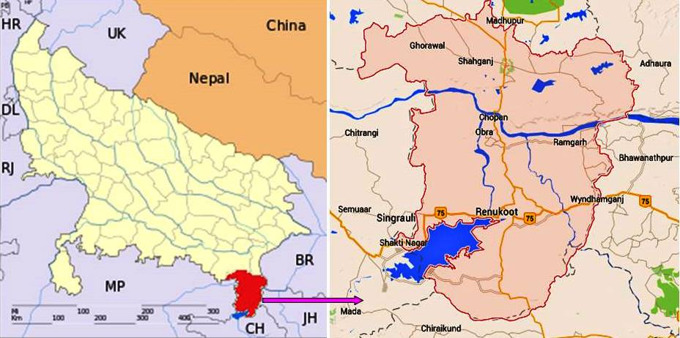
Figure 1.

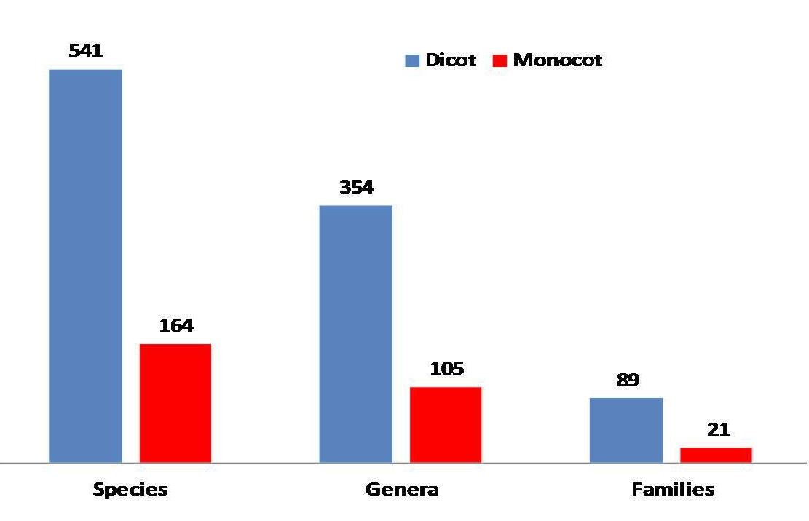
Figure 2.
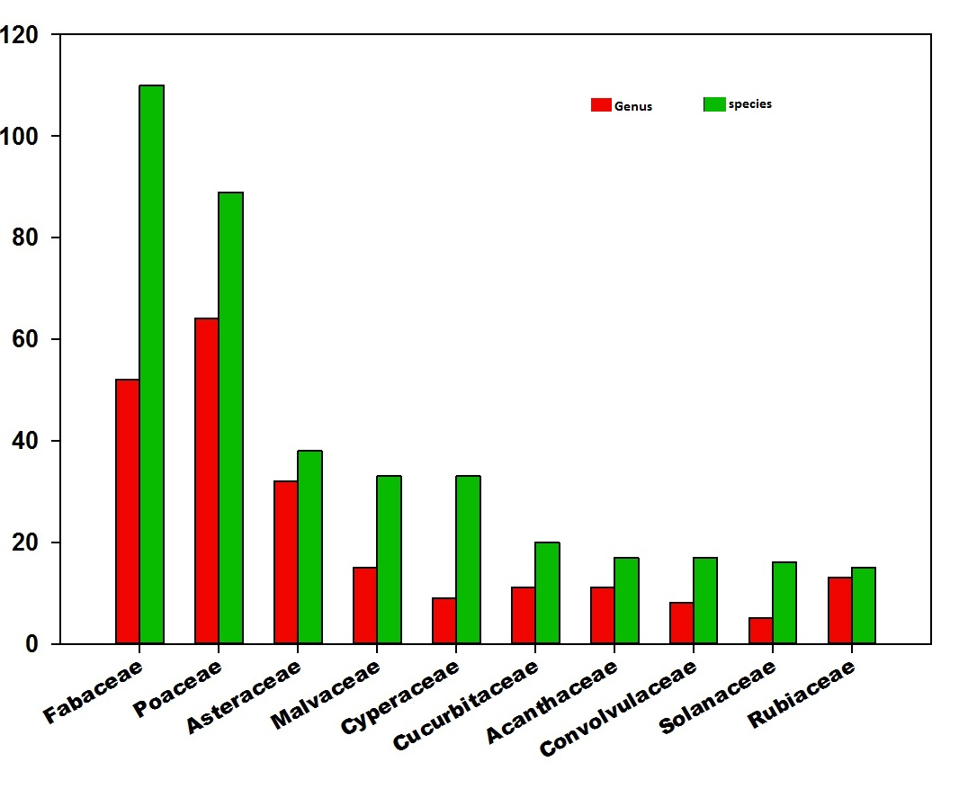
Figure 3

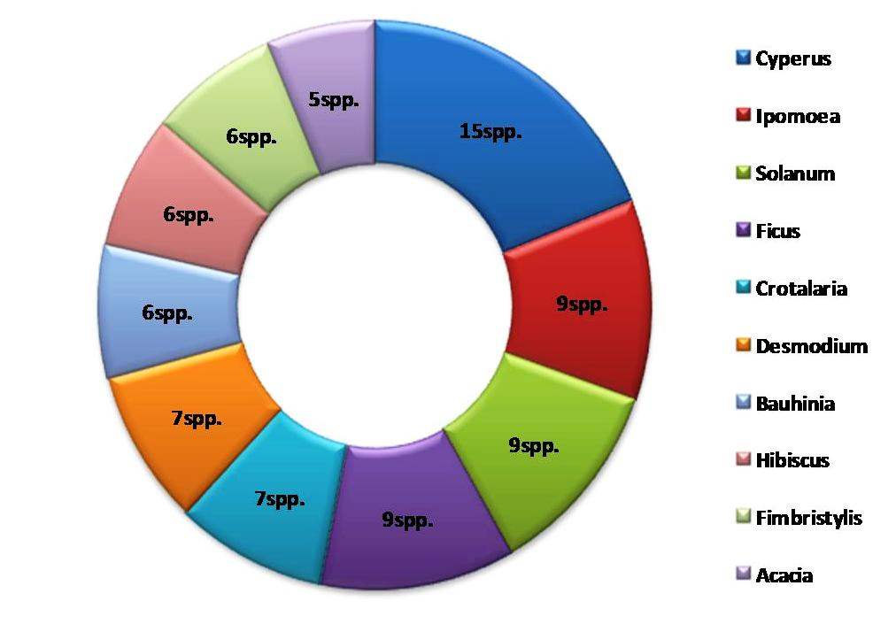
Figure 4.
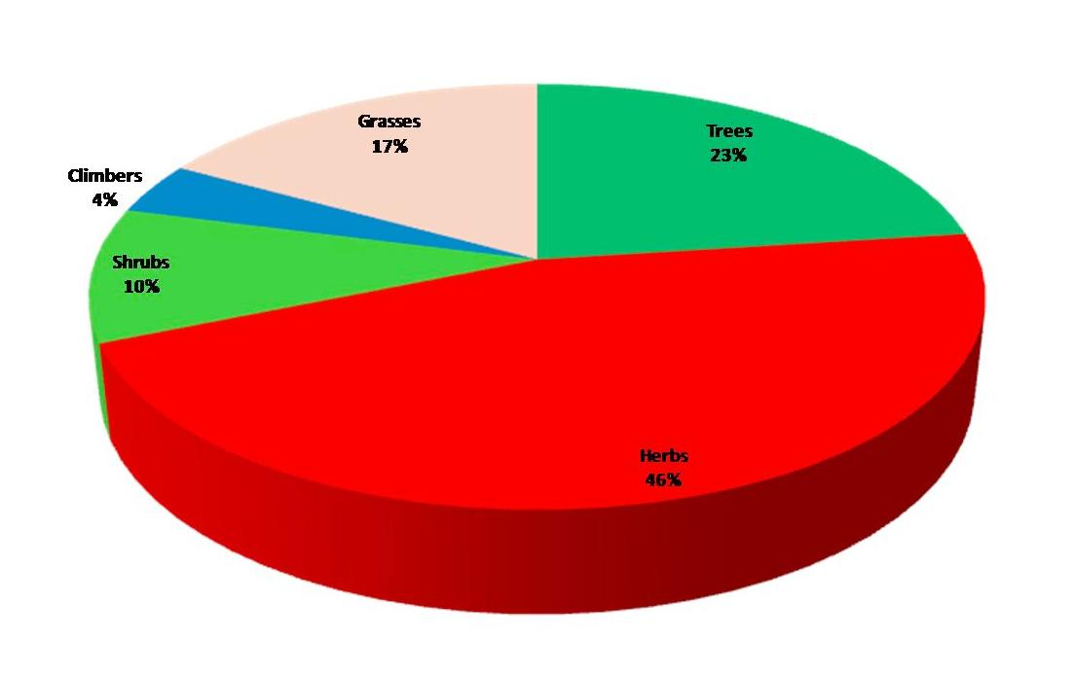
Figure 5.
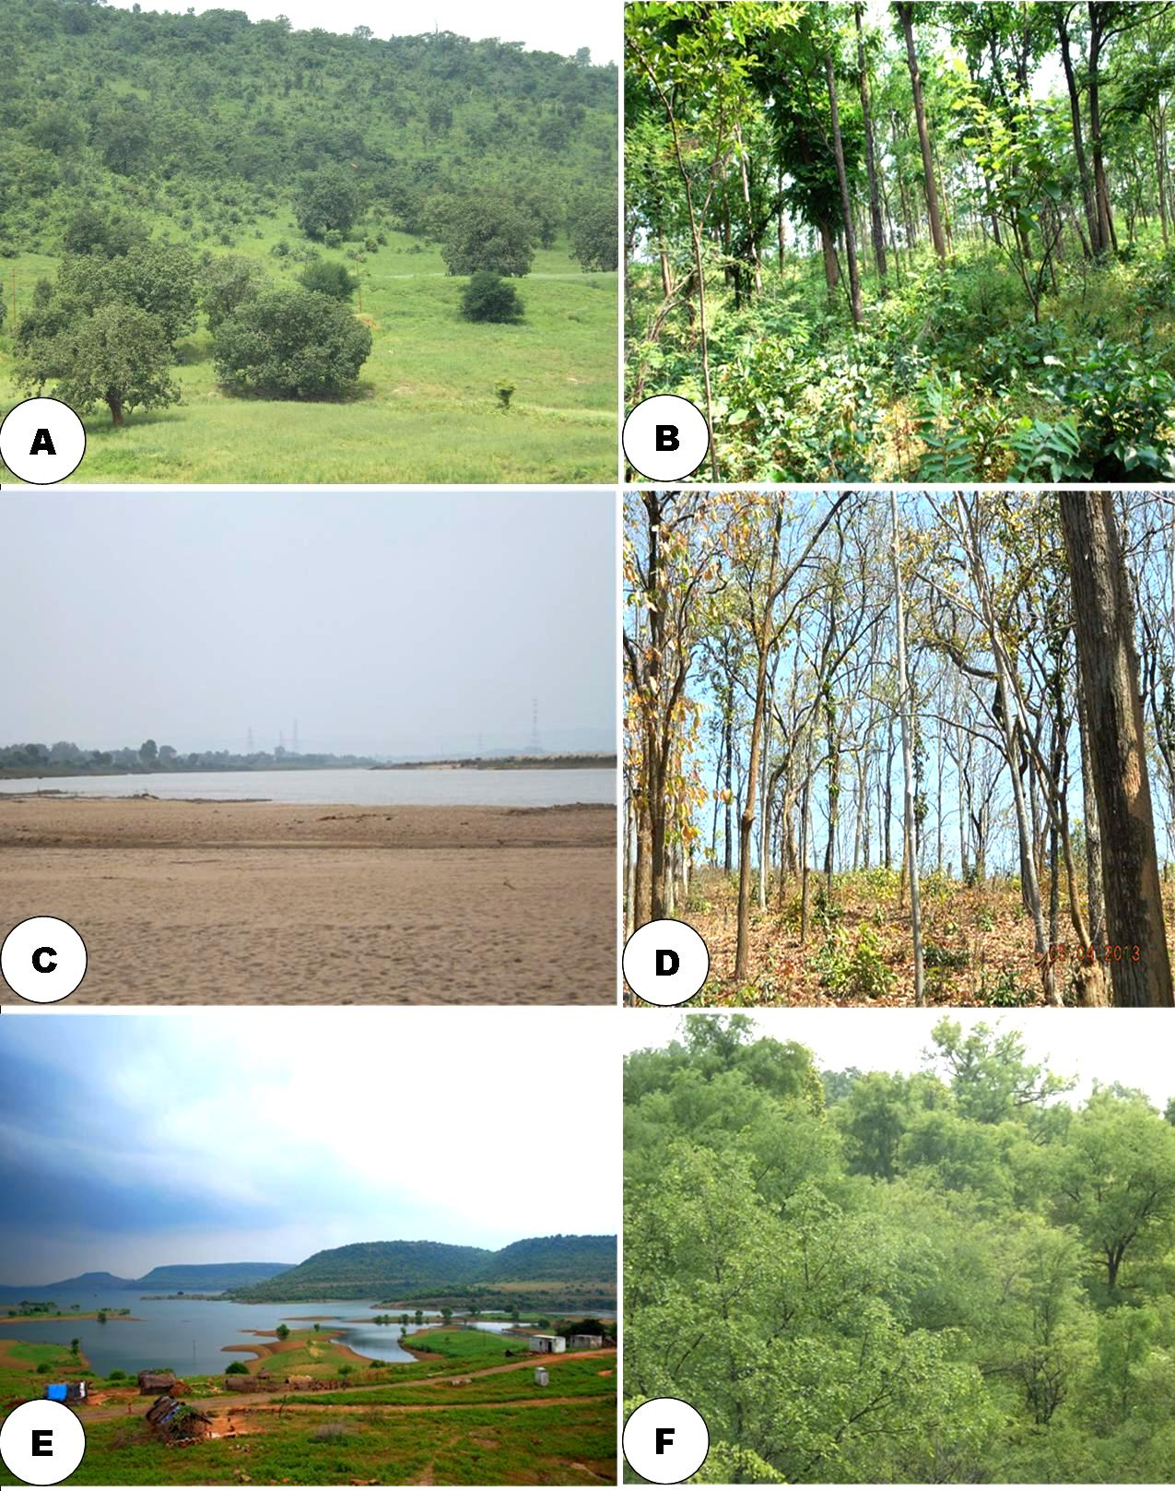

Image 1.
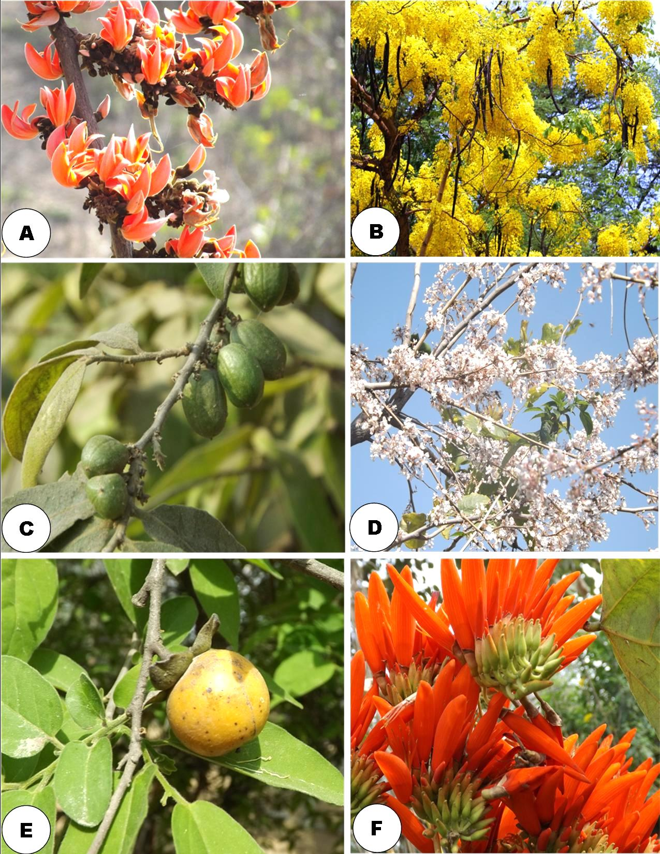
Image 2.
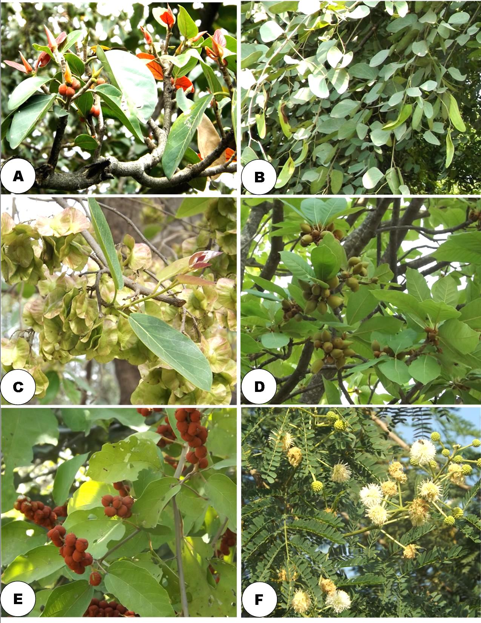
Image 3.
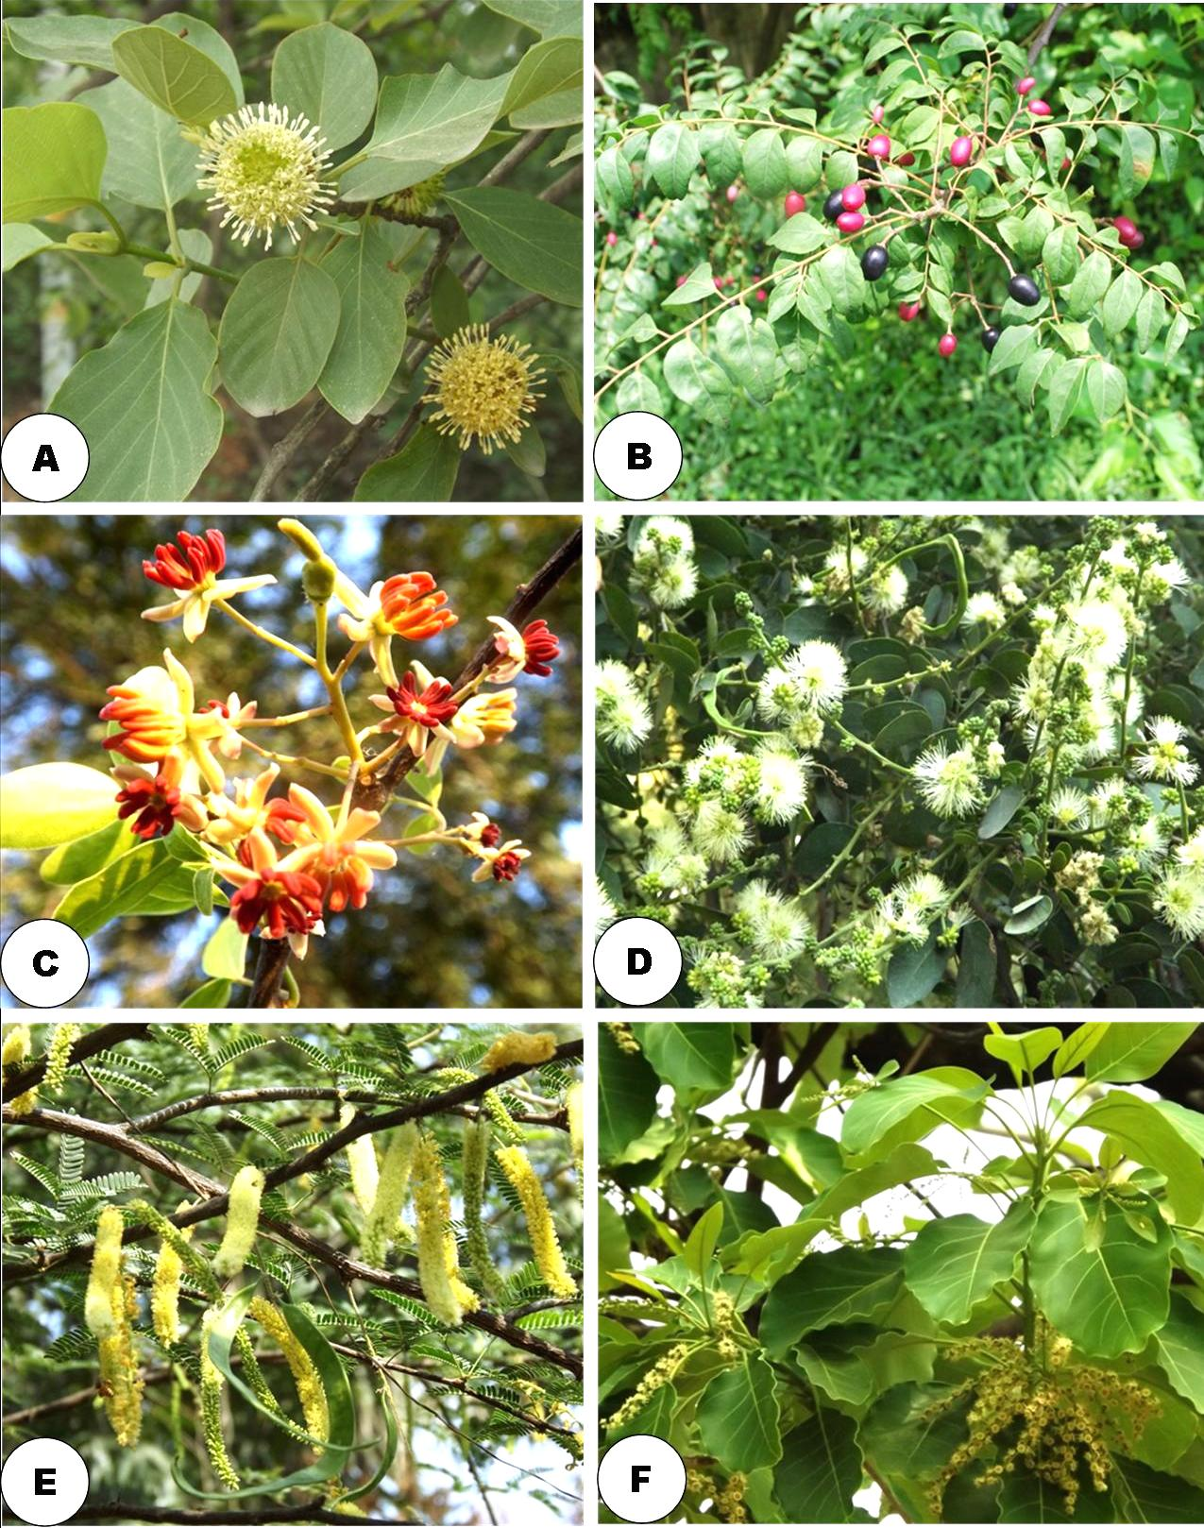
Image 4.

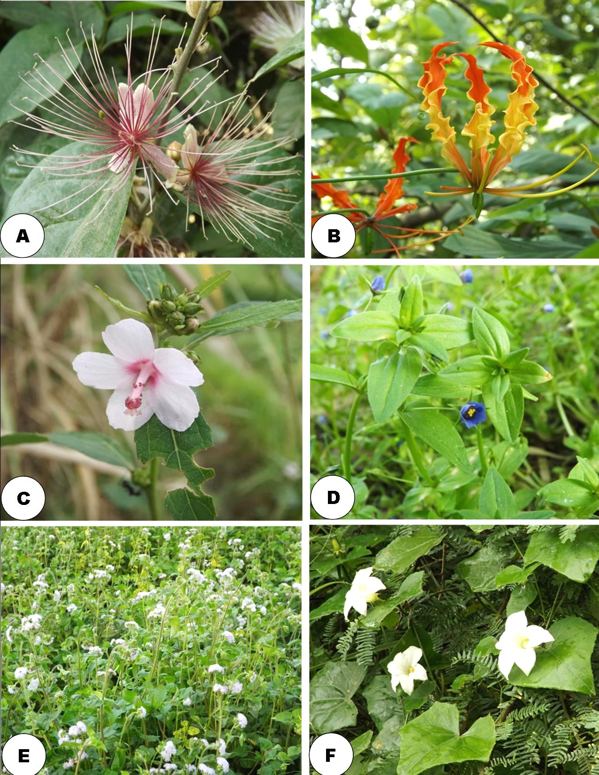
Image 5.
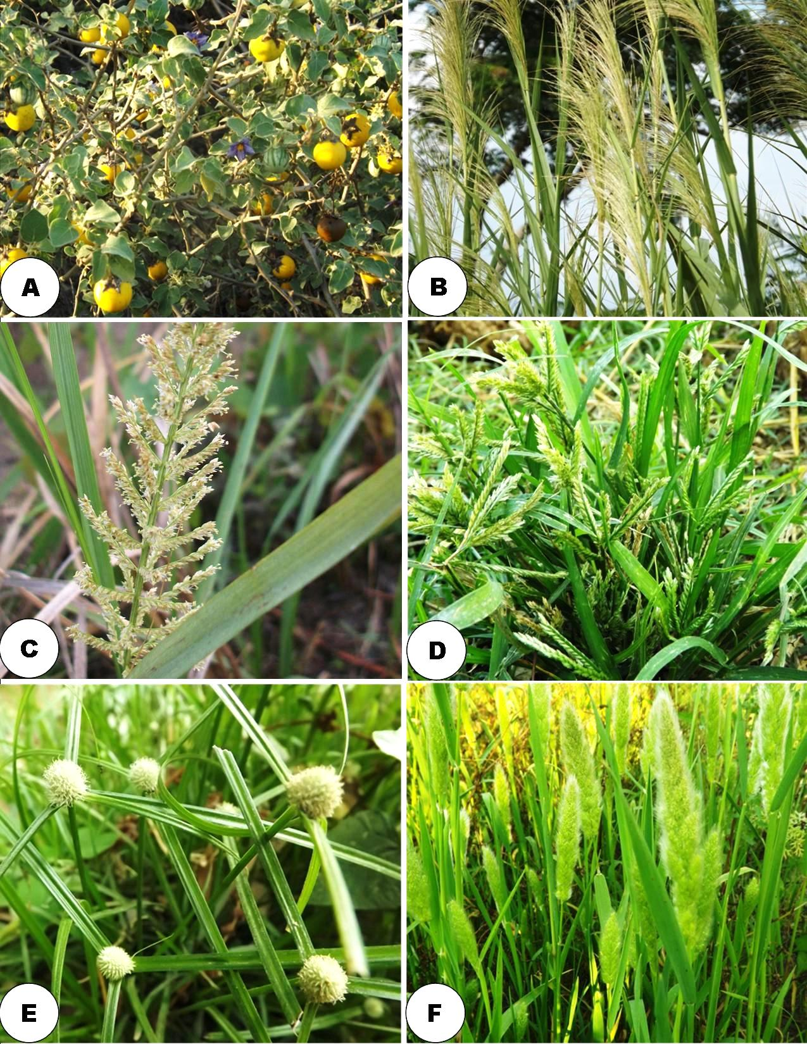
Image 6.
Captions
Table 1: List of species
Figure 1: Study site; Sonbhadra District Uttar Pradesh. Source: Uttar Pradesh map from: https://commons.wikimedia.org/wiki/File:Uttar_Pradesh_locator_map.svg and Sonbhadra map from: https://www.google.co.in/maps/place/Sonbhadra,+Uttar+Pradesh
Figure 2: Analysis of Dicot and Monocot taxa
Figure 3: Largest families
Figure 4: Largest genera
Figure 5: Species in diffent life forms
Image 1: General views of the forest (Photo credit: A. K. Kushwaha)
Image 2: A: Butea monosperma (Lam.) Taub.; B: Cassia fistula L.; C: Casearia tomentosa Roxb.; D: Desmodium oojenenensis (Roxb.) H. Ohasi; E: Diospyros Montana Roxb.; F: Erythrina stricta Roxb. (Photo credit: A. K. Kushwaha)
Image 3: A: Ficus benghalensis L.; B: Hardwickia binata Roxb.; C: Holoptelea integrifolia ( Roxb.)Planch.; D: Madhuca longifolia (J.Koenig ex L.) J.F.Macbr.; E: Mallotus philippensis (Lam.) Müll.Arg.; F: Leucaena leucocephala (Lam.) de Wit (Photo credit: A. K. Kushwaha)
Image 4: A: Mitragyna parvifolia (Roxb.) Korth.; B: Murraya koenigii (L.) Spreng; C: Limonia acidissima Groff; D: Pithecellobium dulce (Roxb.) Benth.; E: Prosopis juliflora (Sw.) DC.; F: Terminalia bellirica (Gaertn.) Roxb. (Photo credit: A. K. Kushwaha)
Image 5: A: Capparis zeylanica L.; B: Gloriosa superb L.; C: Urena lobata L.; D: Anagallis arvensis L.; E: Ageratum conyzoides (L.) L.; F: Coccinia grandis (L.) Voigt (Photo credit: A. K. Kushwaha)
Image 6: A: Solanum incanum L.; B: Arundo donax L.; C: Desmostachya bipinnata (L.) Stapf; D: Eleusine indica (L.) Gaertn; E: Kyllinga brevifolia Rottb.; F: Polypogon monspeliensis (L.) Desf. (Photo credit: A. K. Kushwaha)

