Title: Diversity and Distribution of Freshwater Turtles (Class: Reptilia, Order: Testudines) in Goa, India.
Authors: Trupti D. Jadhav
Department of Zoology,
Goa University, Taleigao Plateau,
Goa-India
Email: truptijadhav2@gmail.com (Corresponding Author)
2) Nitin S. Sawant
Goa State Council for Science and Technology,
Department of Science and Technology. Saligao, Goa India
Email: nitinnature@yahoo.co.in
3) Soorambail. K. Shyama
Department of Zoology,
Goa University, Taleigao Plateau,
Goa-India
Email: skshyama@gmail.com

Abstract

Freshwater turtles symbolize a key component of biodiversity in the aquatic ecosystem, of the 289 living species of turtles and tortoises in the world 33 species are recorded from India. However, the number of freshwater turtle and tortoise species found in the State of Goa is debatable. No study specific to Goa region has been carried out on freshwater turtles. Therefore baseline data on diversity and distribution of freshwater turtles is scanty. Thus the present study was conducted to identify the lacuna which will further aid in identifying the threats and device appropriate conservation methods. The diversity and distribution of freshwater turtles was investigated in 172 sites in Goa from June 2012 – May 2015. A total of 337 specimens of two native and one introduced species of freshwater turtles belonging to two families viz., Trionychidae (Indian Flap-shell Turtle, Lissemys puncata), Emydidae (Indian Black Turtle, Melanochelys trijuga; Red eared Slider, Trachemys scripta elegans) were identified. Melanochelys trijuga (52.23%) was abundant and most widely distributed and was recorded from 132 sites followed by L. punctata (46.88%) which was reported from 113 sites whereas, T. scripta elegans (0.89%) was rare and was recorded from two sites. The present study reports the presence of three species of freshwater turtles in Goa Melanochelys trijuga is generalized in habitat selection thus making them the widely distributed species in the State of Goa and L. punctata is more specific in habitat selection thus restricting their range to coastal, middle level plateau and foothills of Western Ghats.

Keywords: Diversity, distribution, freshwater, turtle.

Introduction
Freshwater turtles symbolize a key component of biodiversity in the aquatic ecosystem, aiding other animals and plants. They not only form the major component of freshwater biomass but also participate in the interacting web and co-dependent species thus constituting a energetic operation of ecosystem. Without turtles, those aquatic ecosystems would progressively degrade in ways are yet to be understood, and would undergo the loss of biodiversity (Iverson 1982; Congdon and Gibbons 1989).

Turtles belong to the order Chelonia/Testudines, sub-order Cryptodira of class Reptilia and comprises of 13 identified families. These include freshwater turtles (Family- Emydidae and Trionychidae), marine turtles (Family- Cheloniidae and Dermochelyidae) and land tortoises (Family- Testudinidae) (Smith 1933). Ernst et al. (2005) reported about 289 living species of turtles and tortoises, which are found in different habitat of the world. India hosts the richest turtle diversity in the world (Iverson 1992) with 33 species of Chelonians of the world. It comprises of 24 freshwater, five marine and four land tortoises (Bhupathy 2009).

Three species of Testudines, namely, Nilssonia leithii, Vijayachelys silvatica and Indotestudo travancorica (tortoise) are endemic to India. Vijayachelys silvatica and Indotestudo travancorica are endemic to Western Ghats, whereas, Nilssonia leithii is endemic to Peninsular India (Deepak and Vasudevan 2009). However, the number of freshwater turtle and tortoise species found in Goa is debatable as some authors (Tikader and Sharma 1985) reported the presence of two species Lissemys punctata punctata and Melanochelys trijuga trijuga in Goa while the distribution of Trionyx leithii and Geochelon elegans in Peninsular India. Pradhan (2008) reports the presences of four species, three freshwater species namely, Trionyx leithii, Lissemys punctata punctata and Melanochelys trijuga and one tortoise Geochelone elegans. Murthy and Das (2009) reported the presence of specimens of two species in the collection of Zoological Survey of India namely, Lissemys punctata punctata and Melanochelys trijuga trijuga from few localities in Goa while others (Srivastava and Nigam 2009) reported the presence of only one species from Goa, namely Lissemys punctata punctata.

No study specific to Goa region has been carried out on freshwater turtles. Therefore baseline data on existence of freshwater turtles is scanty and data on distribution of of freshwater turtles is lacking. For managing and conserving the natural habitat, information on distribution of a species is imperative (Rubin et al. 1998). With scarce information available on the diversity and distribution of freshwater turtle species in Goa (India) the present study was conducted to identify the same which will further aid in identifying the threats and device appropriate conservation methods.

Materials and Methods
Study Area
Goa is the smallest state of the Indian sub-continent and is located along the central-west coast of India (Fig. 1), It lies between latitude 14º51’ to 15º48’ N and longitude 73º41’ to 74º 20’ E. The mountainous region of the Sahyadris in the East, the middle level plateaus in the center and the low-lying river basins with coastal plains are three main physical divisions (Rao 1985–86). The average rainfall is 2500 mm to 3000 mm and the mean daily temperature is around 30º C and maximum temperature rises to 36º C. The climate is humid throughout the year, with humidity level ranging from 75% – 95% in the monsoon. The main feature of the climate is the south-west monsoon, which occurs between June and September. Champion and Seth (1968) classified the major forest types of Goa into west coast tropical evergreen, west coast semi-evergreen and southern moist deciduous forest.

Methodology
Potential sites (rivers, wetlands, streams, ponds, agricultural land and forest areas) were visited and transect walk were carried out to see turtles in wild throughout the geographical region of Goa, 172 sites were surveyed across as shown in Fig. 1. The sites were randomly selected and were readily accessible. The study was conducted from June 2012 – May 2015 across seasons (summer - March to May, monsoon - June to August, post monsoon – September to November and winter - December to February) following the methodology of Akbar et al. (2006). Active searches in the undergrowth were carried out using visual encounter method (Litzgus and Mousseau 2004). Basking turtles were observed and directly counted. Dip net was used for capturing of turtles (Spinks et al. 2003). Netted animals were counted; their species identified and then released back into the same water. All freshwater turtles encountered during the study were identified up to species level following Smith (1933), Tikader and Sharma (1985) and Das (1985, 2008). Exact location and altitude of the area to depict the pattern of distribution of freshwater turtles were recorded using GPS (Geographical Positioning System). Potentially suitable habitats were also identified. At sites where no turtles were captured or encountered, it was assumed that the site had no turtles or that they occurred at a low density (Lin et al. 2010). Turtles captured opportunistically by local volunteers were also considered.

The distribution of all three species in seven different habitats was tested using two-way ANOVA. The seasonal encounter of the three species across seasons (summer, monsoon, post monsoon and winter) was tested using two-way ANOVA. Difference of p < 0.05 was regarded as statistically significant. All the calculations were carried out using the Microsoft Excel Software 2010.

Results
During the survey conducted from June 2012 to May 2015, a total of 337 individuals (334 individuals of native species and three individuals of introduced species) of three species of freshwater turtles belonging to two families viz., Trionychidae (Indian Flap-shell Turtle, Lissemys puncata), Emydidae (Indian Black Turtle, Melanochelys trijuga; Red eared Slider, Trachemys scripta elegans) were recorded. Melanochelys trijuga (Image 1) as the most abundant species and comprised of 52.23% (n=176) of the total individuals encountered followed by L. punctata (Image 2) comprising of 46.88 % (n=158) and T. scripta elegans (Image 3) comprising of 0.89 % (n=3).

Of the 172 sites surveyed freshwater turtles were encountered at 145 sites. Melanochelys trijuga was abundant and most widely distributed and recorded from 132 sites, followed by L. punctata which was reported from 113 sites and T. scripta elegans was rare and was reported from two sites. At 67 sites both M. trijuga and L. punctata were recorded (Figure 1).

It was observed that the freshwater turtles are active mostly during night, dusk and dawn, exhibiting nocturnal habit. Few individuals were also found while crossing the road. During the day hours they mostly remain submerged in water, burry themselves in soil or hidden in crevices and moist leaf litter. It was observed that M. trijuga and L. punctata were distributed throughout the State of Goa. Except for rocky habitat and mountainous region (Western Ghat) where L. punctata was not recorded. Melanochelys trijuga was recorded in slow and fast-moving rivers and ditches at low and high elevations, in wetlands, agricultural land, ponds and streams on plains, plateaus, mountainous areas and in artificial drainages in urban areas. Whereas, L. punctata was encountered in slow moving waters, wetlands agriculture land, ponds and streams on plains. Trachemys scripta elegans was encountered in pond and river. The number of turtles of all the three species found in different habitat types is given in Figure 2. ANOVA showed that the distribution of freshwater turtles in different habitats was highly significant (df = 12, F = 4.23, p = 0.00024).
Distribution of turtles varied among seasons. During monsoon they were encountered at all 145 sites, whereas, in summer and winter they were observed at 50 and 72 respectively. Highest number of individuals was encountered during monsoon season (Figure 3). ANOVA showed that the encounter of freshwater turtles varied significantly with seasons (df =6, F= 1.44, p = 0.24).

Discussion
Reptile species inhabit distinct microhabitat and are not randomly distributed in space (Heatwole 1982). During the present study presence of three species (two native species namely Melanochelys trijuga and Lissemys punctata and one introduced species namely Trachemys scripta elegans ) were reported from the State of Goa. The findings with respect to the two native species augments to that of Murthy and Das (2009) and Tikader and Sharma (1985). However, the presence of Trionyx leithii was not reported during the present study. The presence of T. scripta elegans was recorded for the first time in the state of Goa. Trachemys scripta elegans is naturally distributed in the Mississippi Valley area (Pendlebury 2006). Trachemys scripta elegans was imported to other countries in pet tarde (Pendlebury 2006) which led to illegal trade (Pupins 2007). Thus, the presence of T. scripta elegans in Goa can be ascribed to the illegal pet trade. However it’s impact on the native turtle species in Goa needs to be investigated.

It was observed that M. trijuga and L. punctata were widely distributed and occupied all the potential habitats (agricultural fields, ponds, wetlands, gardens, drainages, rivers and streams) throughout the State of Goa. Similar habitats were reported by Tikader and Sharma (1985) for both the species and by Hoassain et al. (2008) for L. punctata. However, L. punctata was not reported from hilly areas of Western Ghats during the present study and M. trijuga occupied all the possible habitats including drainages in the urban setup. M. trijuga was found to be the most abundant species (52.22%) followed by L. punctata (46.88%) and T. scripta elegans which was the rarest and contributed to (0.89%). Lissemys punctata preferred agricultural fields (37.97%), ponds (28.48%) and wetlands (20.25%) and was rarely sighted in streams (5.69%), Gardens (1.27%) and river (0.63%). However, no individuals of L. punctata were found in drainages. The highest encounters of L. punctata were in the agricultural fields and lowest in river and gardens. This suggests that L. punctata prefers marshy areas and stagnant waters which might assist in burrowing thus providing protection from predators. This also elucidates their absence in hilly regions where the stream beds consists mostly of pebbles and rocky habitat which possibly will not serve as a good refuge ground. Hossain et al. (2008) reported that marshlands and agricultural fields were the most preferred habitats of L. punctata followed by ponds, streams and lakes.

On the contrary M. trijuga preferred streams (30.11%), agricultural lands (26.7%) and ponds (22.16%) followed by wetalands (6.81%), rivers (5.68%), drainages (2.84%) and gardens (1.14%). Thus suggesting that M. trijuga can acclimatize to all habitat types. The distribution of all the three species in different habitats was highly significant.

The encounter of the freshwater turtles in different seasons was significant when tested statistically. Highest numbers of individuals were encountered in monsoon and post monsoon season as compared to summer and winter, this may be attributed to the favorable climatic conditions and rich prey base. Whereas, in summer and winter the resources required for survival are limited thus restricting their distribution. Similar observations are made in other groups of reptiles such as snakes by Sawant et al. (2010) and Sun et al. (2001).
Thus, the present study reports the presence of three species of freshwater turtles in Goa namely M. trijuga, L. punctata and T. scripta elegnas. Melanochelys trijuga is generalized in habitat selection thus making them the widely distributed species in the State of Goa and L. punctata is more specific in habitat selection thus restricting their range to coastal, middle level plateau and foothills of Western Ghats

Reference
Akbar, M., Mushtaq-ul-Hassan, M. & Z. Nisa (2006). Distribution of Freshwater Turtles in Punjab, Pakistan. Caspian Journal of Environmental Science 4(2): 142-146.

Bhupathy, S (2009). Status, Distribution and Ecology of the Indian Flaphell turtle, Lissemys Punctata, pp. 91-94. In: Vasudevan, K (eds.). Freshwater Turtles and Tortoises of India, ENVIS Bulletin: Wildlife and Protected Areas. Wildlife Institute of India, Dehradun, 177 pp.

Champion, H. G. & S. K. Seth (1968). A Revised Survey of the Forest Types of India. Government of India Press, New Delhi, 104 pp.

Congdon, J. D., & J. W. Gibbons (1989). Biomass productivity of turtles in freshwater wetlands: a geographic comparison, pp. 583-591. In: Sharitz, R.R. & J. W. Gibbons (eds.). Freshwater Wetlands and Wildlife. Dept. of Energy Symp, US, 61, 1265 pp.

Das, I. (1985). Indian Turtles a Field Guide. World Wide Fund for Nature-India, New Delhi. 119 pp.

Das, I. (2008). A Photographic Guide to Snakes and Other Reptiles of India. Om Books International, New Delhi, 144 pp.

Deepak, V. & K. Vasudevan (2009). Endemic turtles of India, pp. 25- 42. In: Vasudevan, K. (eds.). Freshwater Turtles and Tortoises of India. ENVIS Bulletin: Wildlife and Protected Areas vol 12(1). Wildlife Institute of India, Dehradun, 177 pp.

Ernst, C. H., Altenburg, R. G. M. & R . W. Barbour (2005) . Turtles of the World. CD catalogue. ETI Information Services Ltd. Ver. 1.2. Information about, and samples of the catalogue are available on http:// www.eti.uva.nl/Turtles/Turtles.html.

Heatwole, H. (1982). A review of structuring in herpetofaunal assemblages, pp. 1-19. In: Scott N. J. Fr. (eds.). Herpeto- logical communities: a symposium of the society for the study of Amphibians and Reptiles and the herpetologists league. Fish and wildlife service, US, 239 pp.

Hossain, L., Sarker, S.U., & N. J. Sarker (2008). Ecology of Spotted Flapshell Turtle, Lissemys punctata (Lacepede, 1788) In Bangladesh. Ecoprint 15: 59-67.

Iverson, J. B. (1982). Biomass in turtle populations: a neglected subject. Oecologia 55: 69-76.

Iverson, J. B. (1992). A revised checklist with distribution maps of the turtles of the world. Privately Printed, Richmond, Indiana, 363 pp.

Lin, Y., Shenghai, W., Lin, T ., Mao, J. & T. Chen (2010). Population status and distribution of the Endangered yellow margined box turtle Cuora flavomarginata in Taiwan. Oryx, 581-587.

Litzgus, J. D. & T. A. Mousseau (2004). Demography of a Southern Population of the Spotted Turtle (Clemmys guttata). Southeastern Naturalist 3(3): 391-400.

Murthy, B. H. C. & I. Das (2009). The turtle collection of the zoological survey of India Kolkata, India, pp. 15-24. In: Vasudevan, K. (eds.). Freshwater Turtles and Tortoises of India. ENVIS Bulletin: Wildlife and Protected Areas vol 12(1). Wildlife Institute of India, Dehradun, 177 pp.

Pendlebury, P. (2006). Trachemys scripta elegans (reptile). Invasive Species Specialist Group. http://www.issg.org/database/species/ecology.asp?si=71&fr=1&sts.

Pradhan, M. S. (2008). Reptilia, pp. 281-364. In: Director (eds.). Fauna of Goa, State Fauna Series. Zoological Survey of India, Kolkata, 531 pp.

Pupins, M. (2007). First report on recording of the invasive species Trachemys scripta elegans, a potential competitor of Emys orbicularis in Latvia. Acta Universitatis Latviensis, 723 Biology: 37–46.

Rao, R. S. (1985–86). Flora of Goa, Diu, Daman, Dadra and Nagarhaveli. Vol 1 and 2. Botanical Survey of India, Calcutta, 546 pp.

Rubin, E. S., Boyee, W. M., Jorgenren, M. C., Torres, S.G., Hayes, C. L., “O”Bien, C. S. & D. A. Jessup (1998). Distribution and abundance of Bighorn sheep in the Peninsular Ranges. California Wildlife Society Bulletin 26: 539-551.

Sawant, N. S., Jadhav, T. D. & S.K. Shyama (2010). Distribution and abundance of pit vipers (Reptilia: Viperidae) along the Western Ghats of Goa, India. Journal of Threatened Taxa 2(10): 1199-1204.

Smith, M.A. (1933). The fauna of British India including Ceylon and Burma: Reptilia and Amphibia. Vol.1. Loricata, Testudines Taylor and Francis, London. (Reprinted 1974, 1995 by Today and Tomorrow’s Printers and Publishers, NewDelhi, xxviii + 185 pp.

Spinks, P. Q., Paulya, G. B. , Crayonc , J. J. & H.B. Shaffera (2003). Survival of the western pond turtle (Emys marmorata) in an urban California environment. Biological Conservation 113: 257–267.

Srivastav, A. & Nigam, P. (2009). Freshwater Turtles of India: Status and Management in Captivity, pp. 133-141. In: Vasudevan, K. (eds.). Freshwater Turtles and Tortoises of India, ENVIS Bulletin: Wildlife and Protected Areas vol 12(1). Wildlife Institute of India, Dehradun, 177 pp.

Sun, L., Shine, R., Zhao, D. & Z. Tang (2001). Biotic and abiotic influences on activity patterns of insular pit-vipers (Gloydius shedaoensis, Viperidae) from north-eastern China. Biological Conservation 97: 387-398.

Tikader, B. K. & R.C. Sharma (1985). Handbook: Indian Testudines. Zoological Survey of India, Calcutta, 156 pp .

Figure 1: Map of Goa, India showing the distribution of Melanochelys trijuga, Lissemys punctata and Trachemys scripta elegans.

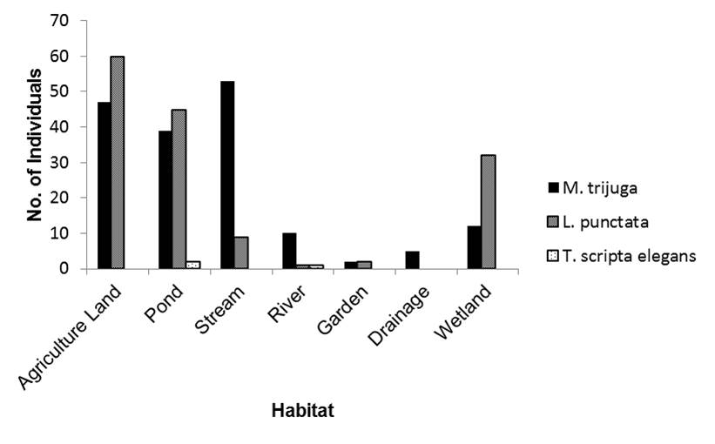
Figure 2: Graph showing the total number of individuals of Melanochelys trijuga, Lissemys punctata and Trachemys scripta elegans found in different habitat types.

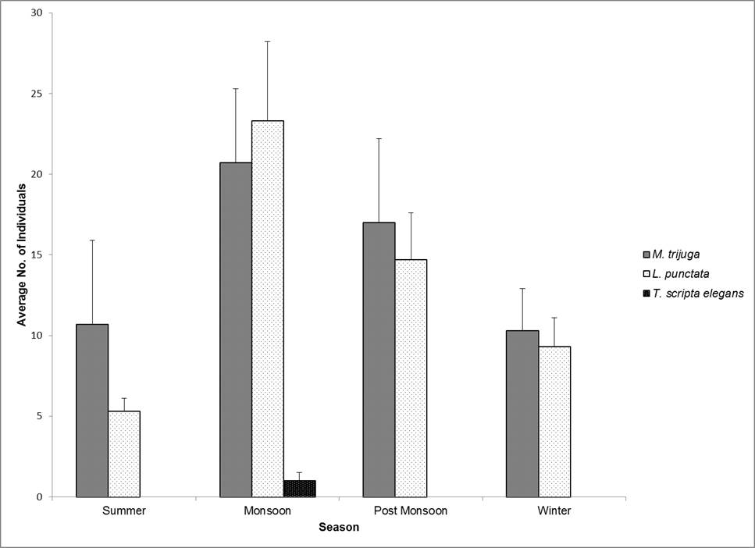
Figure 3: Graph showing the total number of individuals of Melanochelys trijuga, Lissemys punctata and Trachemys scripta elegans during different seasons.

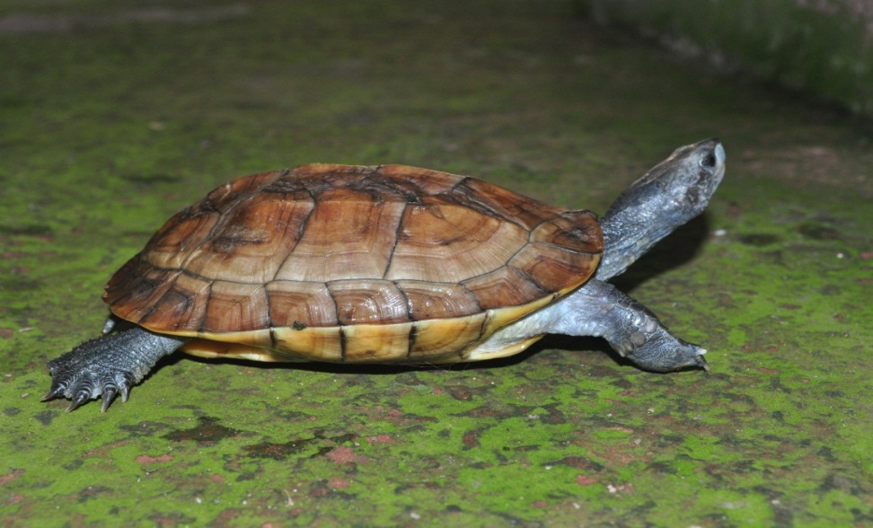
Image 1: Melanochelys trijuga

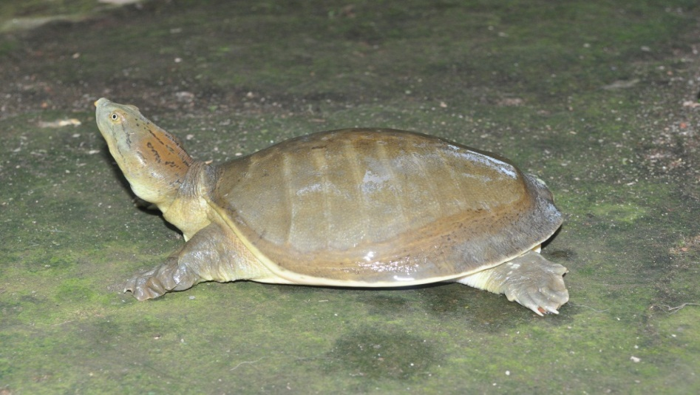
Image 2: Lissemys punctata
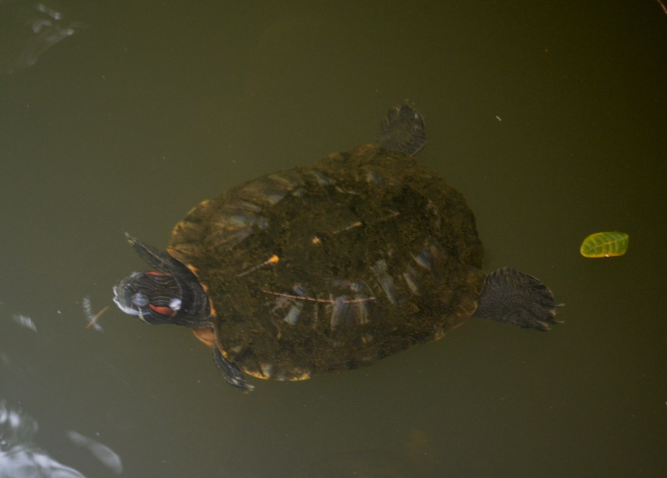
Image 3: Trachemys scripta elegans

